Mining Residue Contacts in Proteins Using Local Structure Predictions
Mohammed J. Zaki, Shan Jin and Chris Bystroff
IEEE International Symposium on Bio-Informatics and Biomedical Engineering, November 08 - 10, 2000, pp.168
Abstract
In this paper, we develop data mining techniques to predict 3D contact potentials among protein residues (or amino acids) based on the hierarchical nucleation-propagation model of protein folding. We apply a hybrid approach, using a hidden Markov model (HMM) to extract folding initiation sites, and then apply association mining to discover contact potentials. The new hybrid approach achieves accuracy results better than those reported previously.
- Introduction
The folding process could be dissected into 3 phases.
- initiation
- propagation
- condensation
We say that two residues a_{i}, a_{j} in a protein are in contact if | a_{i}-a_{j} |<7Å
- Hybrid Mining Approach
We first use an HMM to predict local substructures within the protein. We then use meta-level mining on the output of the HMM using association rule mining.
- HMMSTR：an HMM for local structure in proteins
HMMSTR has a highly branch topology and captures recurrent local features of protein sequences and structures that transcend protein family boundaries. The model extends the I-sites library by describing the adjacencies of different sequence-structure motifs as observed in the protein database.

- Data Format and Preparation

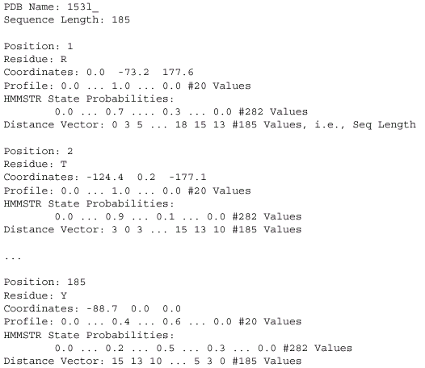

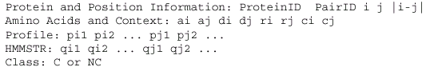
- Association Mining on the Pairs Database
5.1 Mining on Known Examples

  - Mining：We use CHARM to mine all the frequent closed itemsets (F).
  - Counting：We compute the support of all itemsets in F in the non-contacts database.
  - Pruning：We remove all itemsets which have a greater probability of occurrence in the non-contact database than in the contact dataset.

5.2 Testing on Unknown Examples

- Evidence Calculation
- Prediction

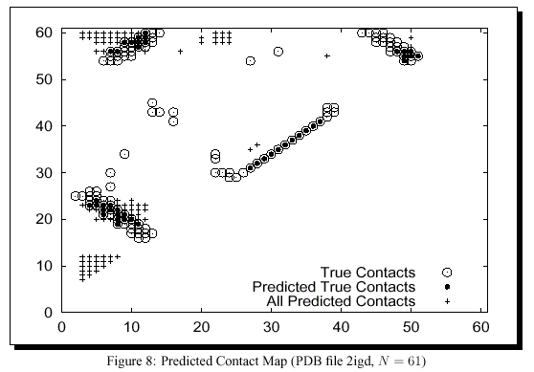

Created by : Rei-Sing Cheng
Date : Feb. 21, 2003

