Efficient Primer Design Algorithms
Thomas K¨ampke1, Marku Kieninger and
Michael Mecklenburg
Bioinformatics, Vol. 17, No.3, pp.214-225, Mar. 2001
Abstract

Primer design involves various parameters such as string-based alignment scores, melting temperature, primer length and GC content. This entails a design approach from multicriteria decision making. Values of some of the criteria are easy to compute while others require intense calculations.
1.Introduction

Primer assessment extends beyond string matching and involves criteria including the proximity between primer melting temperatures, minimization of hybridization effects between forward and reverse primers, and avoidance of hybridization of primers with themselves.

2.Aggregation of Assessments for Ordinary PCR

- A primer pair (p, q) is assigned the scoring vector:

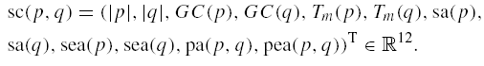

- The ideal score vector or reference vector:
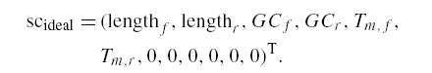

- The final assessment of a primer pair (p, q) can be its deviation from the reference in terms of the l1-distance

- The PCR primer computation is formalized as the reference point approximation problem:
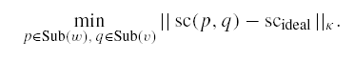
3. Melting Temperature and GC Content

Tm(p) =4 #G in p + 4 #C in p + 2 #A in p + 2 #T in p.

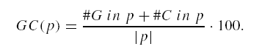
4. Self Annealing and Self-end Annealing
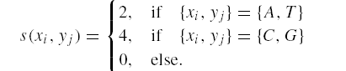
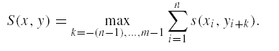
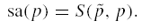 Self annealing
 self-end annealing

5.Criteria for Primer Pairs

Both primers p =(p1, . . . , pn) and q= (q1, . . . , qm)are arranged in all overlapping antithetic alignments and maximum scores are taken. Formally,
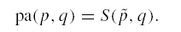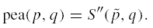
6. Dynamic Programming for Enumeration

- DYNSA
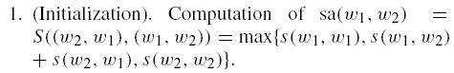
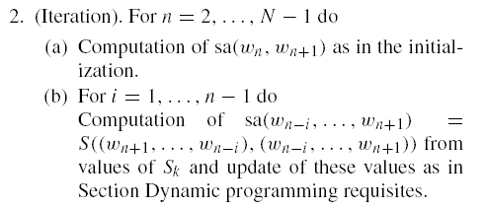
- DYNPA
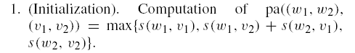
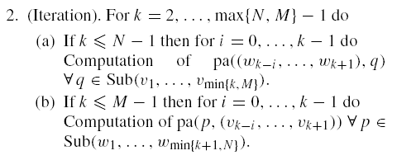
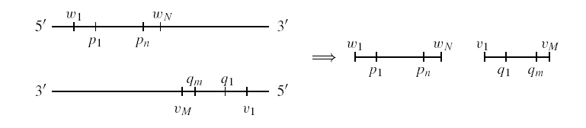
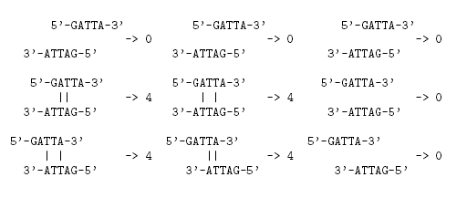
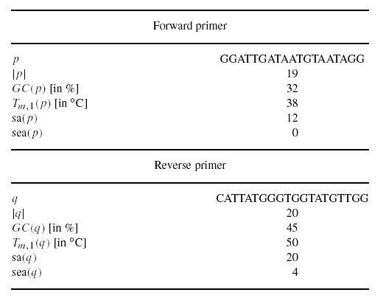
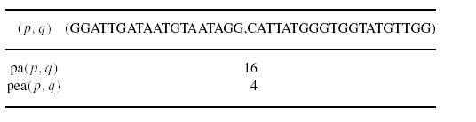
Created by : Wei-Tin Liu
Date : Mar. 26, 2003

