The Massively Parallel Genetic Algorithm for RNA Folding:

MIMD Implementation and Population Variation
Bruce A. Shapiro, Jin Chu Wu, David Bengali and Mark J. Potts
BIOINFORMATICS, Vol. 17, no. 2, pp. 137-148, 2001

1. Introduction
A massively parallel genetic algorithm (GA) has been applied to RNA sequence folding on three computer architectures. The algorithm was originally designed and developed for a 16 384 processor SIMD (Single Instruction Multiple data) MasPar MP-2.More recently it has been adapted to a 64 processor MIMD (Multiple Instruction Multiple Data) SGI ORIGIN 2000, and a 512 processor MIMD CRAY T3E.

2. Massively Parallel GA for RNA Folding
- The GA generates a stem pool consisting of all fully (or partially) zipped stems from the given RNA sequences.
- Each Processor holds one RNA structure.
- On each processor, the GA selects two RNA structures, P1 and P2, to be parent structures. This selection is done from the set of nine structures including the structure on the processor itself and the structures on its eight-neighbor processors.
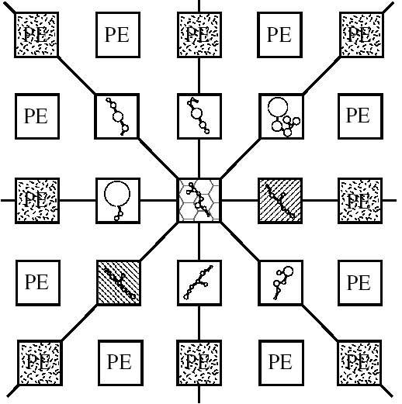
- On each processor, the GA picks stems randomly from the stem pool to from two child-structures, C1 and C2.
- Finally, the GA performs a crossover operation between (P1,P2) and (C1,C2), distributing stems from P1 and P2 into C1 and C2 to complete the two new structures.
- This implies that the generations proceed, more and more processors most likely contain the same RNA structure. When a relative error that is computed from the weighted average of free energies obtains a value less than a specified uncertainty, the GA is said to converged and thus is terminated.
3. The Boltzmann filter
In addition to passing the geometric conflict test, a stem making a structure more stable is accepted without any condition. However, a stem, making a structure less stable, accepted or rejected based on the transition probability (less than it, accepted).
4. The GA on a MIMD Machine
- Each Physical processor’s local memory divides into many location as a virtual processor.
- Minimized the amount of communication that occurs between physical processors. As a result, the best configuration must be as square as possible.
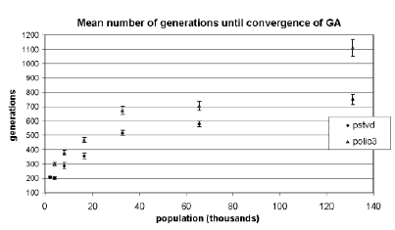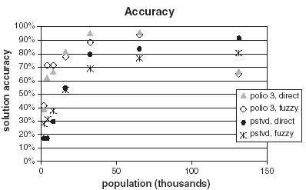
5. Conclusion
The scalable design permits the running of the algorithm on a single processor SGI OCTANE as well as a 512 processor SGI ORIGIN 2000 or a 2048 processor CRAY T3E.

Created by: Chia-Chang Wang
Date: July 3, 2003

