DNA Solution of the Maximal Clique Problem
Qi Ouyang, Peter D. Kaplan, Shumao Liu, Albert Libchaber
Science, Vol. 278, Issue 17, pp. 446-449, Oct. 1997
Abstract
The maximal clique problem has been solved by means of molecular biology techniques. A pool of DNA molecules corresponding to the total ensemble of six-vertex cliques was built, followed by a series of selection processes. The algorithm is highly parallel and has satisfactory fidelity. This work represents further evidence for the ability of DNA computing to solve NP-complete search problems.
- Definition of the Maximal Clique Problem
- Clique: defined as a set of vertices in which every vertex is connected to every other vertex by an edge

- Maximal clique problem: Given a network containing N vertices and M edges, how many vertices are in the largest clique?

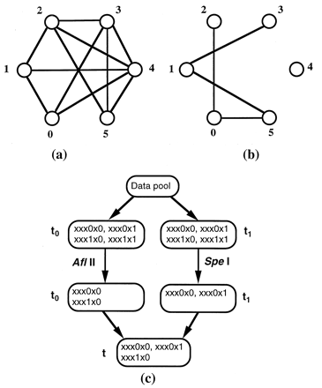
- Algorithm
- Step 1.
Make the complete data pool : For a graph with N vertices, e ach possible clique is represented by an N-digit binary number

1: a vertex in the clique 0: a vertex out of the clique

example: clique (4,1,0) -> binary number 010011

- Step 2.
Find pairs of vertices in the graph that are not connected by an edge
(0,2) (0,5) (1,5) (1,3)

- Step 3.
Eliminate from the complete data pool all numbers containing connections in the complementary graph
xxx1x1 or 1xxxx1 or 1xxx1x or xx1x1x

- Step 4.
Sort the remaining data pool to find the data containing the largest number of 1’s -> the clique with the largest number of 1’s tells us the size of the maximal clique
- Experiment
- Complete data pool
    - two DNA sections

    - $P_{i}V_{i}P_{i+1}$ for even i
$\overline{P_{i+1}V_{i}P_{i}}$ for odd i ,

bit’s value (V_{i}) V₀~V₅ 0 bp when V_{i} =1
10 bp when V_{i} =0
position value (P_{i}) P₀~P₆ 20 bp

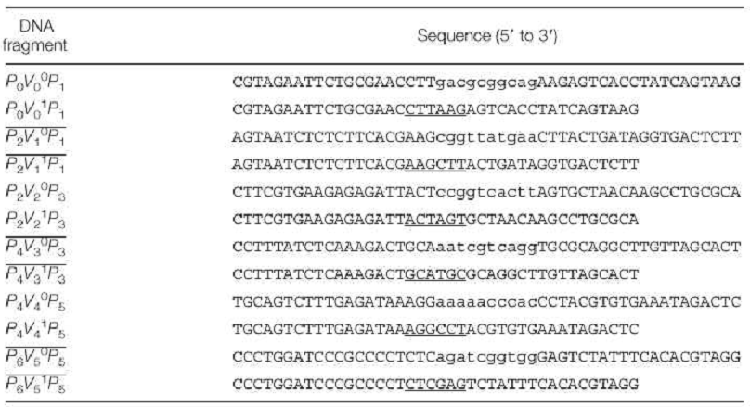

- parallel overlap assembly
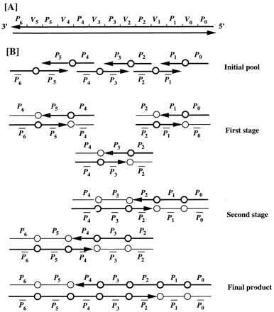

- Digestion with restriction enzyme

Elimination all strings connected by edges
–xxx1x1, 1xxxx1, 1xxx1x, xx1x1x

- Check the remaining data DNA to find the DNA sequence with shortest length by electrophoresis.

- Read the answer by molecular cloning.
- Conclusion
Created by: Hung-Wei Huang
Date: Oct. 17, 2003

