A Parallel Image Compression Scheme Based on Fractal Coding and Vector Quantization
K. Masselos, K. Karagianni, Y. Karayiannis, and T. Stouraitis
ICECS ’96, pp. 712-715
Abstract
In this paper the combination of fractal coding with a codebook to create a still image coder with the capability of parallelization is presented. For each image block the search for the best approximation is performed only inside its corresponding region, instead of the whole image as in traditional fractal coding schemes. To compensate for a possible quality degradation, the search is extended to a codebook.
- Introduction
- The Proposed Algorithm

- Experimental Results

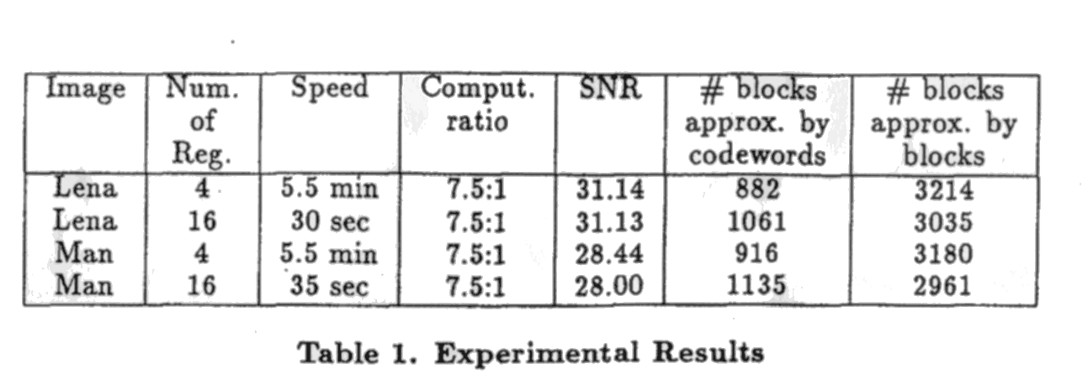

- Architecture

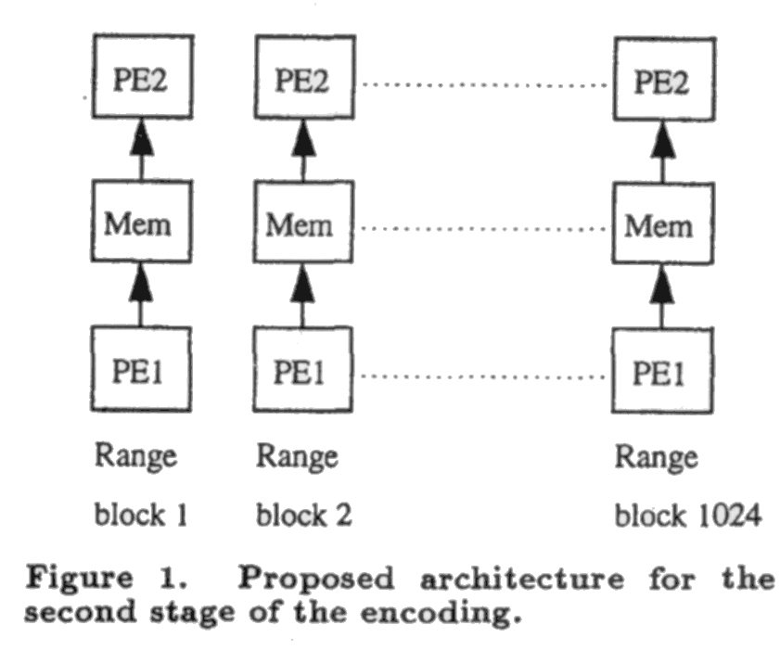
- Conclusions
Creator: Shin-Si Chen
Date: May 5, 1999

