A Scalable Parallel Approach to Vector Quantization
Ayşegül Çuhadar, Demetrios Sampson and Andy Downton
Real-time Imaging 2, p241-247, 1996
- Introduction
The major limitation of VQ is the high computational complexity required for the selection of the best-matched codevector available in the VQ codebook. Although the encoding task in VQ is computationally expensive, it is well suited for parallel processing because of the repetitive nature of the task and the regularity of the image data. In this paper, we present the application of a scalable parallel approach to the implementation of the VQ encoding process.
- Vector Quantization
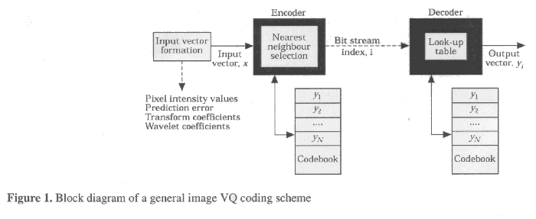
- Approach adopted for parallelization

- Parallelization schemes for VQ
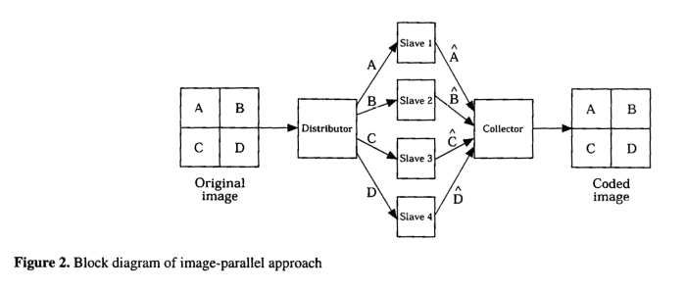
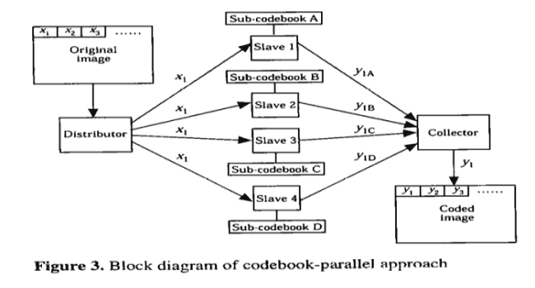
- Experimental results
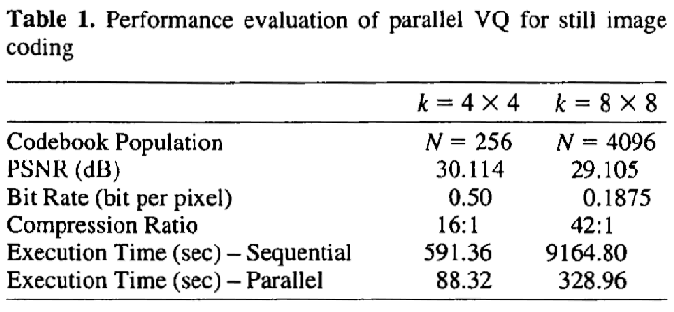
Created by: Shin-Si Chen
Date: Apr. 20. 1999

