Novel Codebook Generation Algorithms for Vector Quantization Image Compression
K. Masselos, T. Stouraitis, C. E. Goutis
Acoustics, Speech and Signal Processing, 1998.Proceedings of the 1998 IEEE International Conference on Volume 5, 1998, pp2661-2664
Abstract
In this paper, two basic techniques are proposed. The first technique takes into consideration specific characteristics of the blocks of the training sequence during the generation of the initial codebook. In this way, the optimization procedure converges fast to a representative final codebook. The second proposed technique extends small codebooks computationally. The main idea is the application of transformations on the codewords. This technique reduces the memory requirements of the traditional vector quantization.
- Introduction
The operation of vector quantization is described by the following equation:
$$\begin{aligned}Q:R^{k}→C \\ C=\left\{y_{1},y_{2},\text{.}\text{.}\text{.}\text{.},y_{N}\right\};y_{i}∈R^{k},∀i=1,2,\text{.}\text{.}\text{.}\text{.},N\end{aligned}$$
$y_{i}=Q(x)$ if $d(x,y_{i})≤d(x,y_{j}),∀i,j=1,2,\text{.}\text{.}\text{.}\text{.},N$
- Codebook Design Techniques
- Proposed Algorithm for Codebook Design
Assuming a size of the training sequence blocks 4x4 pixels, some simplified representative block features are described by the following equations, where X is a block of the training sequence.
$$\begin{aligned}\text{Magnitude}=\sum_{i,j=1}^{4}{X_{\text{ij}}^{2}} \\ {\text{Mean}}_{\text{Value}}=\frac{\sum_{i,j=1}^{4}{X_{\text{ij}}}}{\text{16}} \\ \text{Variance}=\sum_{i,j=1}^{4}{\left|X_{\text{ij}}−{\text{Mean}}_{\text{Value}}\right|} \\ \text{Shape}=\sum_{i,j=1}^{4}{\left|X_{\text{ij}}−R_{\text{ij}}\right|}\end{aligned}$$
Where R is a reference block randomly selected from the training sequence.
Base on these features the initial codebook design procedure requires classification of the blocks with respect to the above features. The selected feature each time is computed for all the blocks in the training sequence.
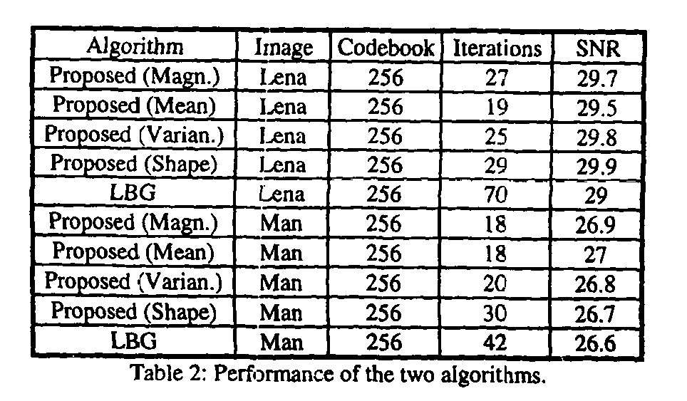
- Computational Codebook Extension
The basic idea is the use of small codebooks generated by any codebook design algorithm which are are computationally extended. This is achieved by applying simple transformations on the codewords during encoding. Two simple transformations are selected: Shifting transformation and isometries. Shifting transformation simply adds a constant value to all the pixels of a codeword or image block. Isometries are transformations that simply shuffle the pixels of an image block or codeword in a deterministic way.
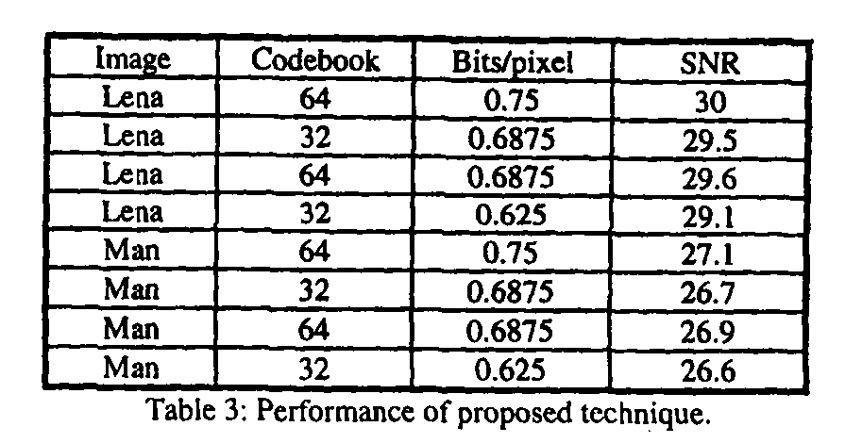
- Conclusions
Created by: Shin-Si Chen
Date: July 27, 1999

