Transportable Agents Support Worldwide Application
David Kotz, Robert Gray and Daniela Rus
Seventh SIGOPS European Workshop 1996 pp. 41- 48
- Transportable autonomous agents
A transportable autonomous agent is a named program that can migrate from machine to machine in a heterogeneous network. Transportable autonomous agents are well suited for the construction of worldwide applications for two reasons:
- They are transportable
- They are autonomous
- Dartmouth’s Agent Tcl project
  - Communication
  - Navigation
  - Disconnected operation
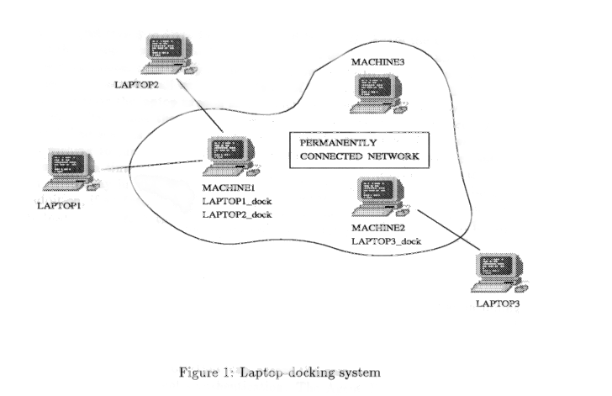
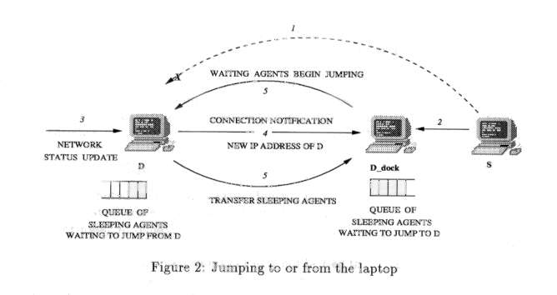
  - Security
  - Resource allocation
  - Graphical interfaces
- Related work
Created by: Shin-Si Chen
Date: Mar. 3, 1999

