Macro-Star Networks: Efficient Low-Degree Alternatives to Star Graphs
Chi-Hsiang Yeh, Emmanouel A. Varvarigos
IEEE Transactions on Parallel and Distributed Systems, Vol.9, No. 10, October 1998, p987-1003
Abstract
We propose a new class of interconnection networks, called macro-star networks, which belong to the class of Cayley graphs and use the star graph as a basic building module.
- Introduction
The purpose of this paper is to develop a new family of parallel architectures that meet the following requirements:
- small node degree,
- small diameter,
- symmetry properties,
- efficient emulation of popular topologies,
- balanced traffic, and
- suitability for VLSI implementation.

An MS(l,n) network has N = (nl + 1)! nodes, degree n+l–1.
Balanced MS networks: An MS(l, n) network with l=Θ(n) is asymptotically within a factor of 1.25 from a universal lower bound.
- Macro-Star Networks
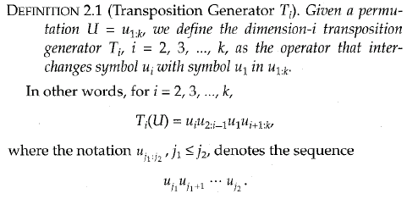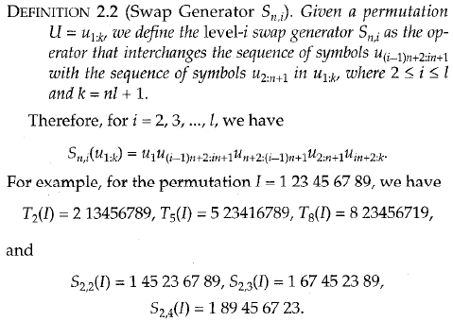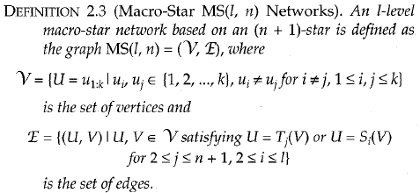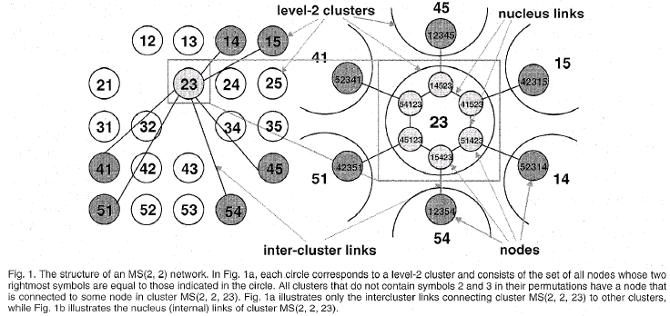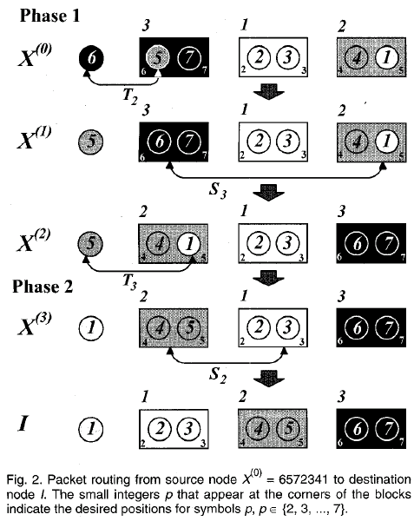
- Routing and Topological Properties
3.1 Routing in an MS Network Based on Any Star-Graph Routing Algorithm
Any Algorithm in an (ln +1)-star under the Single-Dimension Communication (SDC) model can be emulated on the MS(l,n) network with a slowdown factor of three.
3.2 Faster MS Routing Algorithms
The total number of steps required by the routing algorithm is at most equal to $\left\lfloor 2\text{.}5(\text{nl}+l−1)\right\rfloor$ steps.
3.3 Basic Properties
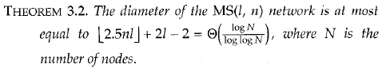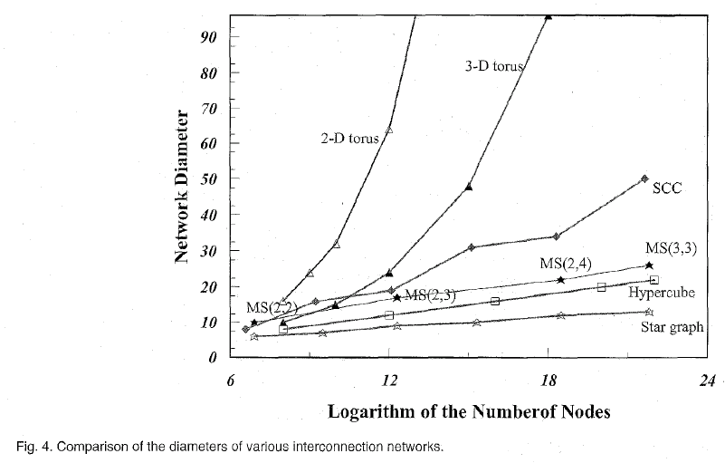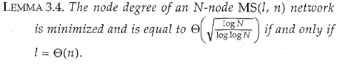
3.4 Near Optimal Diameter
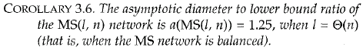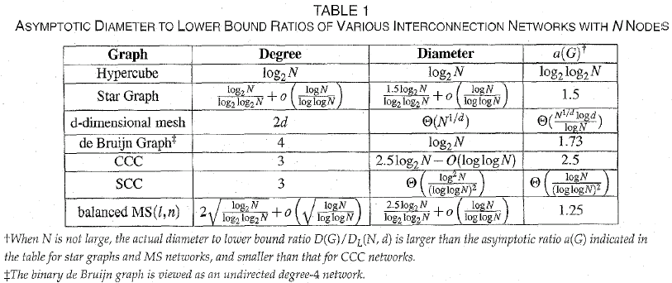
- Parallel Algorithms in MS Networks
4.1 Parallel Algorithms under the Single-Dimension Communication Model
4.2 Emulation of Star Graphs under the All-Port Communication Model
4.3 Embeddings of Trees, Meshes, Hypercubes, and Complete Transposition Graphs
- Conclusions
The MS network and its variant topologies can fit the needs of high-performance interconnection networks and appear to be efficient low-degree alternatives to the star graph for building medium to large-scale parallel architectures.

Created by: Chia-Mao Huang
Date: June 22, 2000

