Automated Image Analysis for Array Hybridization Experiments
Matthias Steinfath, Wasco Wruck, Henrik Seidel, Hans Lehrach, Uwe Radelof and Joho O’Brien
Bioinformatic, Vol. 17, No. 7, pp. 634-641, 2001
- Introduction
Image analysis is a major part of data evaluation for array hybridization experiments in molecular biology. In this paper two different kinds of hybridization experiments are under consideration: Oligonucleotide fingerprinting and complex hybridizations.
- Image rotation
Since the array is often not parallel to the image edge, the estimation of the rotation angle is necessary.
We determine the array rotation as the median of the angles of the four edges relative to the image border. To find the rotation angle of the upper edge of the spot array the following procedure is applied:
- Find for each column x_{j} on the left half of the image the first pixel y_{j} with intensity > 0 ;
- Calculate the histogram of the vertical values of these pixels and determine its first maximum y_{ml} ;
- Take the leftmost column x_{l} for which y_{ml} – 2 < y_{j} < y_{ml} + 2 holds;
- Repeat the above steps for the right half of the image to find the corresponding column, x_{r} and row y_{mr} .
This way we find two points (x_{l}, y_{ml}) and (x_{l}, y_{mr}), which constitutes a line. The angle between this line and upper image edge is taken as rotation angle of the upper edge of the spot array.

- Background noise
If a nylon filter is used as support there are three kinds of background noise: the histogram of pixel intensities has a first maximum for the background, a second if we use nylon filter as support for filter socket and a third if there are enough spots which yield a signal. The histogram of pixel intensities has therefore normally three maxima corresponding to these background noise.

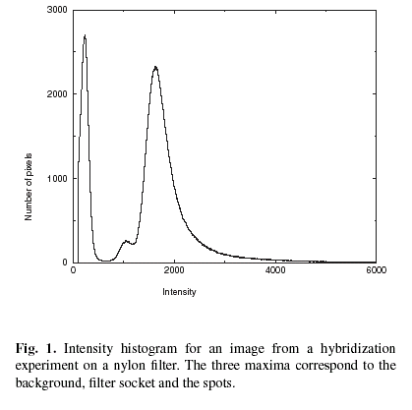
Created by : Jih-Wei Huang
Date : May 16, 2001

