A Parallel Algorithm
for Constructing a Labeled Tree
Yue-Li Wang, Hon-Chan Chen, and Wei-Kai Liu
IEEE Transactions on Parallel and Distributed Systems,
Vol. 8, No. 12, pp. 1236-1240, Dec. 1997

Abstract
A tree T is labeled when the n vertices are distinguished from one another by name such as v1,v2,…,vn. According to Caley’s tree formula, there are n^{n-2} labeled trees on vertices. in this paper, we shall propose an O(logn)time parallel algorithm for constructing a labeled tree by using O(n) processors and O(nlog n) space on the EREW PRAM computational model.
- Introduction
- Algorithm A
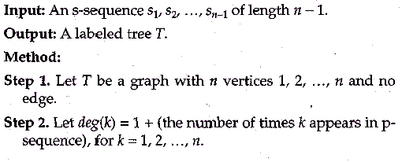
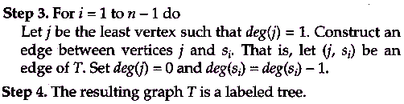
- Algorithm B
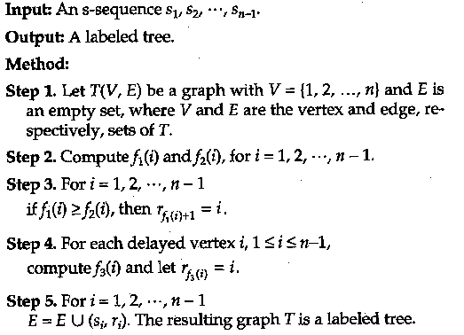
- Concluding Remarks
Another interesting Problem is to design an efficient parallel algorithm for transferring a labeled tree to its corresponding number sequence.

Created by : Kuen-Feng Huang
Date : Mar 7, 2000

