Communication-Efficient Sorting Algorithms on Reconfigurable Array of Processor With Slotted Optical Buses
Mounir Hamdi, Chunming Qiao, Yi Pan, and J. Tong
Journal of Parallel and Distributed Computing Vol.57
1999,p166-187

Abstract
Our parallel sorting algorithms on the 1D RASOB is based on an efficient divide-and-conquer scheme. It sorts N processors in O(k) communication cycles. Sorts N data items on a 2D RASOB of size N in O(k) communication cycles.

Introduction
- Procedure Sort

During iteration I (I= 1 to k):

1. Each processor p(i) broadcasts the data item it holds to p(START_{i}),
p(START_{i+1}), ...,p( END_{i}), including itself, if the Ith most significant bit of its data item is equal to 0. After this step, the RASOB processors will contain a variable number of data items in their respective receiving buffers.

2. Each processor p(i) checks its receiving buffer if it contains an (i - START_{i} + I )th data item. If so , it marks the data down and does a type I replacement which is described in step 5 of the algorithm. Moreover, it clears its receiving buffer. The value of (i - START_{i} + 1) represents the position of p(i) in its subgroup, starting from left to right. Processor p(i) gets the (i – START_{i} + 1 )th data item in order to let the processors on its left get data items of smaller values since the Ith significant bit is 0. As a result, the processors on its left side can form their own subgroup later.

3. This is analogous to Step 1 above. Each processor p(i) broadcasts the data
item it is holding to p( START_{i} ), p( START_{i} + 1), ..., p( END_{i}), including itself, if the Ith most significant bit of its data item is equal to 1. After this step. The RASOB processors will contain a variable number of data items in their respective receiving buffers.

4. Each processor p(i) checks its receiving buffer if it contains an ( END_{i} -i + I )th data item. If so, it marks the data down and does a type II replacement which is described in step 5 of the algorithm. Moreover, it clears its receiving buffer. The value of ( END_{i} - i+1) represents the position of p(i) in its subgroup, starting from right to left. Processor p(i) gets the (END_{i} – i + l)th data item in order to let the processors on its right get data items of larger values since the Ith significant bit is 1. As a result, the processors on its right side can form their own subgroup later.

5. Each processor does a type I replacement or a type II replacement by replacing the data item it is holding with the marked data item.

6. Each processor p(i) sends a message to p(i -1) only if i -1 ≧ START_{i} and sends a message to p(i + 1) only if i +1≦ END_{i} to find out what type of replacement they have performed. In other words, processor p(i) finds out whether the processor on its immediate left and the processor on its immediate right belong to the same group or not since p(START_{i}) has no processor on its immediate left belonging to the same group and p(END_{i}) has no processor on its immediate right belonging to the same group.

7. For each processor p(i), if it has performed a type I replacement and finds that i+ 1 ≦ END_{i} and p(i+1) has performed a type II replacement, then p(i) sends a message to p(START_{i}), p(START_{i}+1),..., p(i) informing them to change their variable END to be equal to i.

8. For each processor p(i), if it has performed a type II replacement and finds that i- 1 ≧ START_{i} and p( i- 1) has performed a type I replacement, then p(i) sends a message to p(i), p(i+ 1), ..., p(END_{i}) informing them to change their variable START to be equal to i.

End {Procedure SORT}

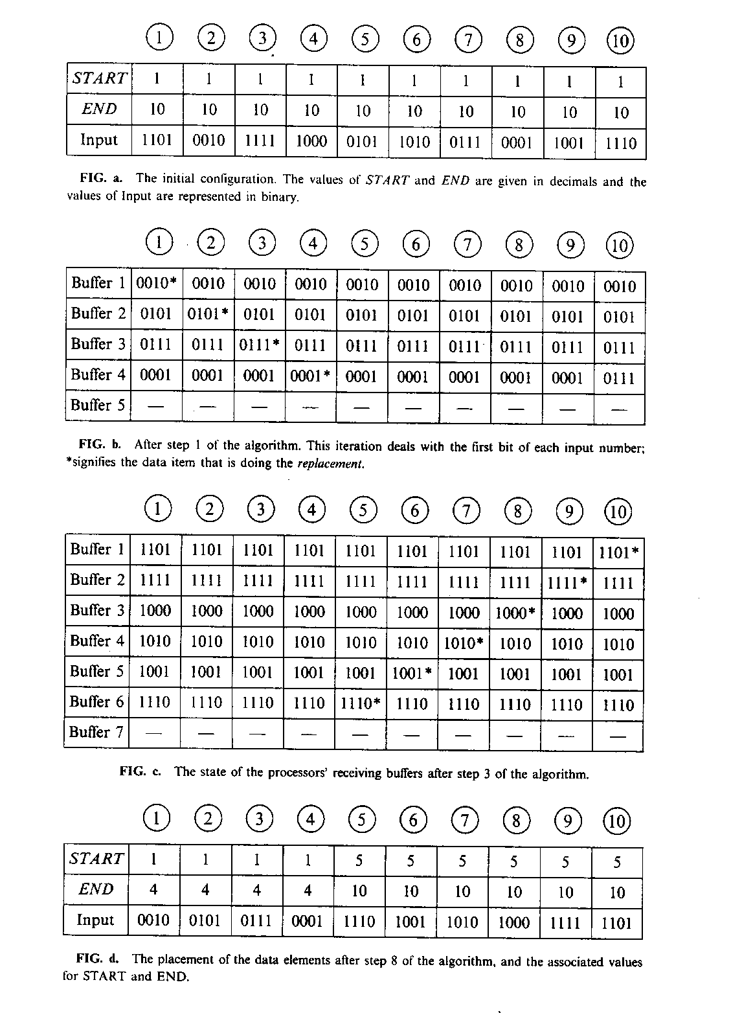

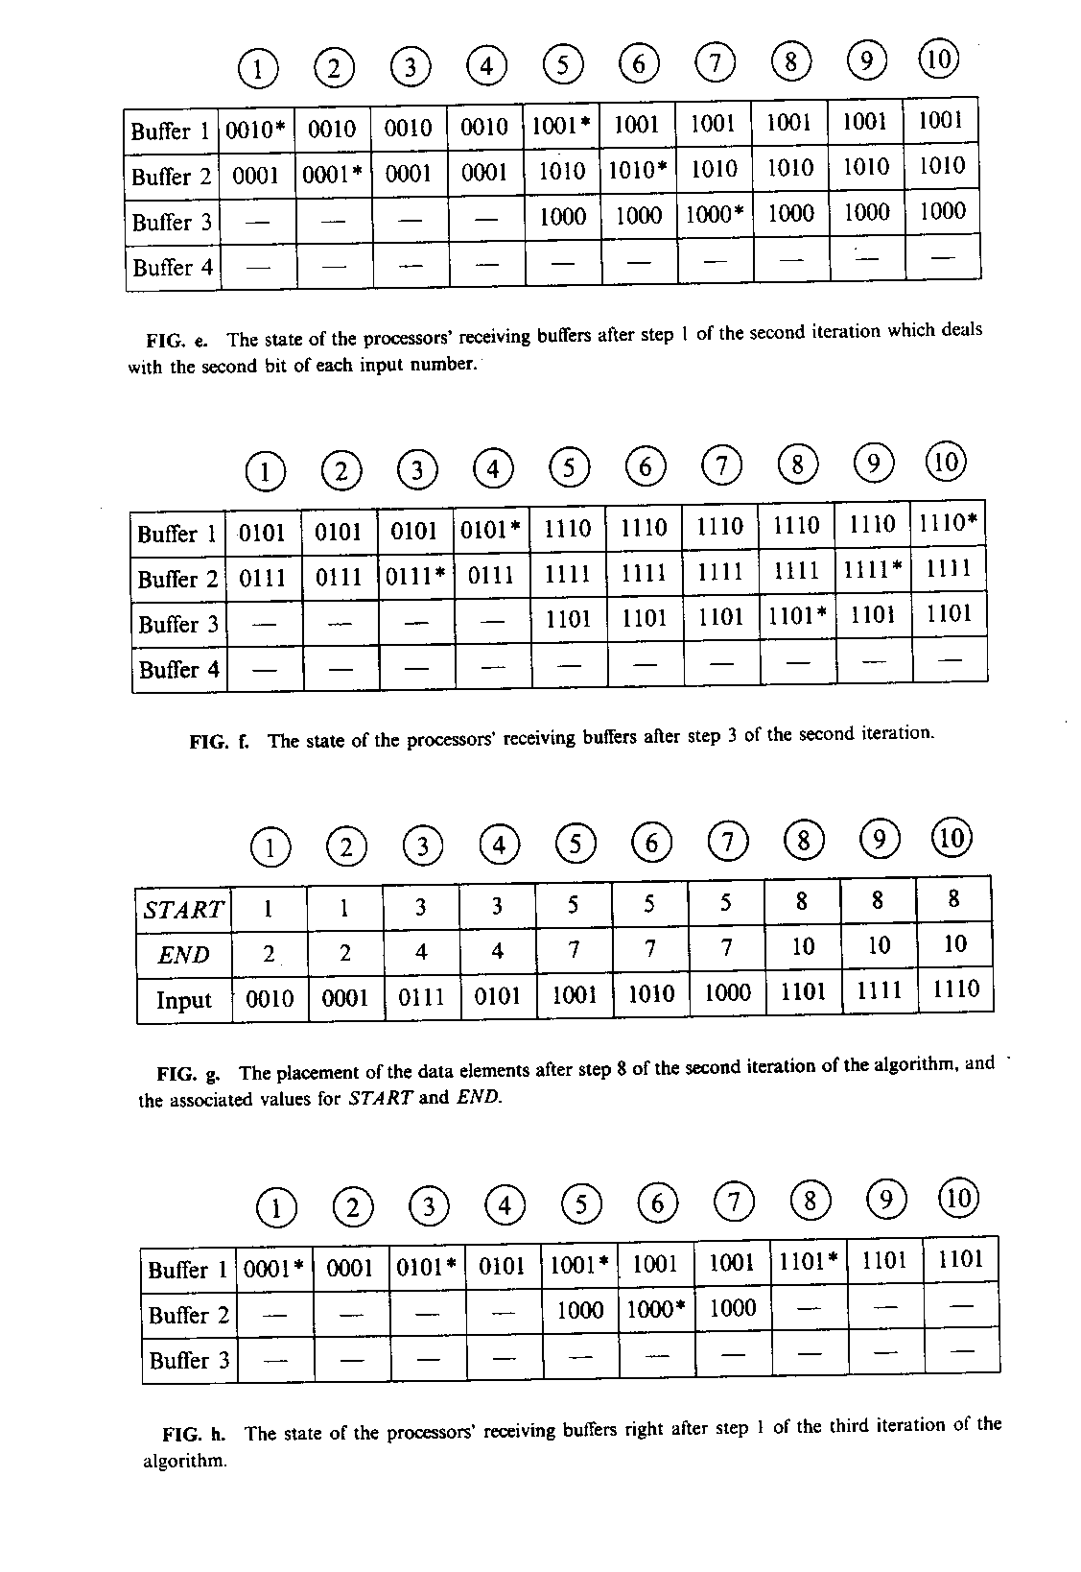

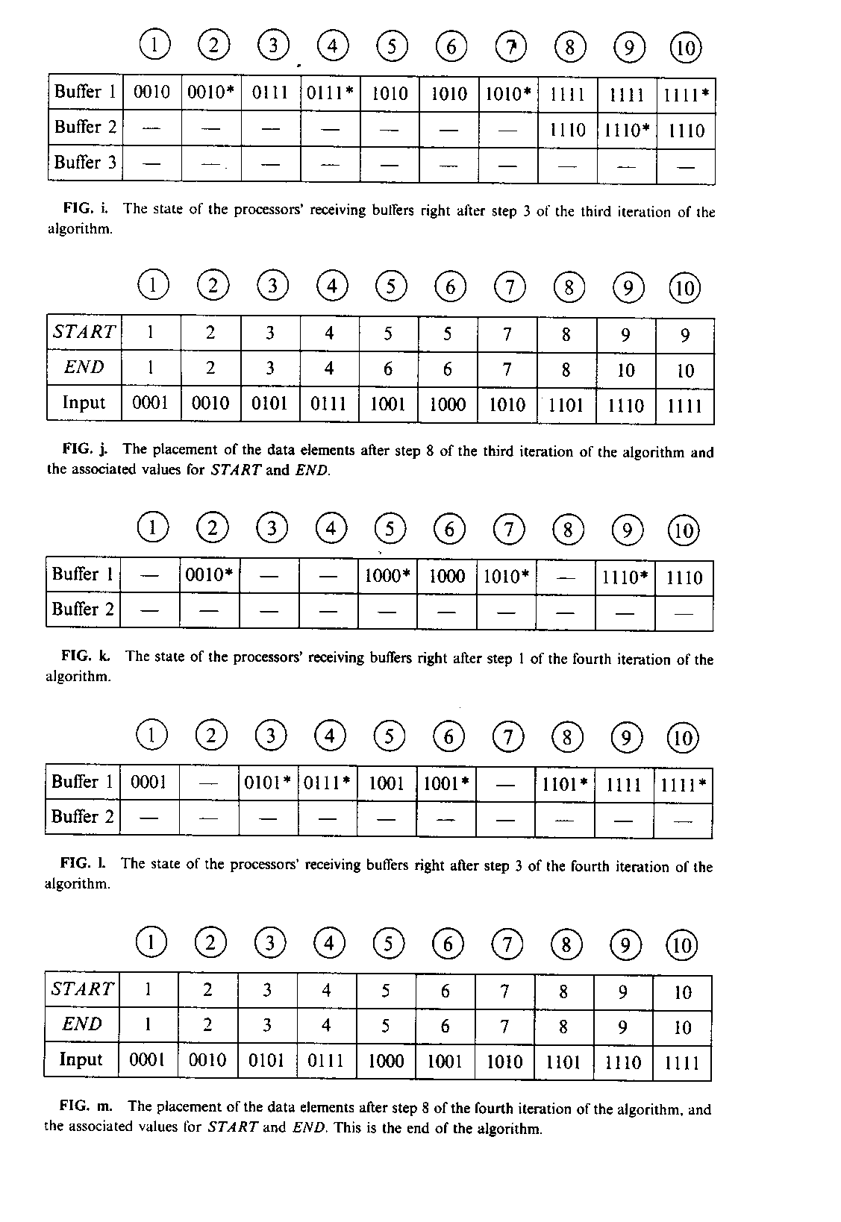
- Rotatesort
Macro BALANCE applies to a subarray of size u x v and consists of three
steps:
a. Sort all columns downward.
b. Rotate each row i rightward by (i mod v) positions.
c. Sort alt columns downward.
Macro UNBLOCK, distributes the data elements of each block among all
columns. It consists of two steps:
a. Rotate each row i rightward by (iS^{1/2} mod S) positions.
b. Sort all columns downward.
Macro SHEAR: equivalent to performing one iteration of the shear-sort
algorithm [ 1 ]. It consists of two steps:
a. Sort all even-numbered rows rightward and all odd-numbered rows
leftward.
b. Sort all columns downward.

The Rotatesort algorithm can be described in terms of these macros as
PROCEDURE Rotatesort.

(1) Perform BALANCE on each vertical slice.
(2) Perform UNBLOCK on the entire array.
(3) Perform BALANCE on each horizontal slice.
(4) Perform UNBLOCK on the entire array.
(5) Perform three iterations of SHEAR on the array.
(6) Sort all rows rightward.

- Conclusion
Created by : Kuen-Feng Huang
Date : Dec. 23, 1999

