Determining Longest Common Subsequences of Two Sequences on a Linear array of Processors
Amar Mukherjee
Application Specific Array Processors,1992.
Proceedings of the International Conference on , 1992 , pp. 526 -537

Abstract
- Introduction
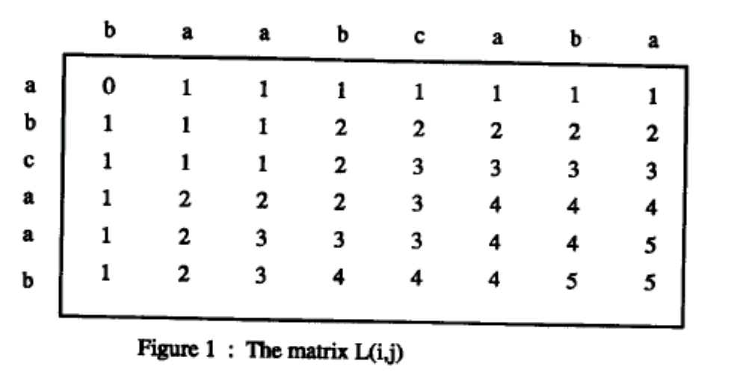
- Boolean matrix
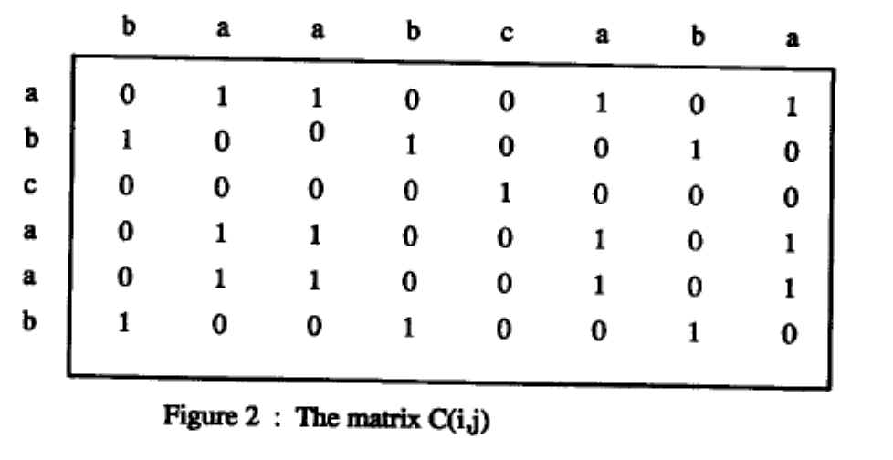
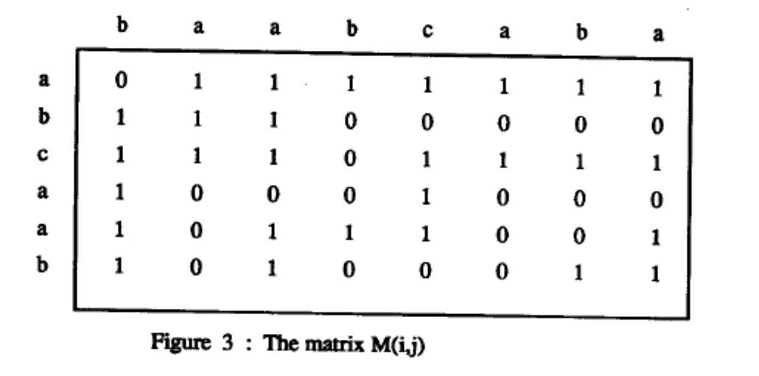
$M(i,j)=\overline{M}(i−1,j−1)[M(i−1,j)+M(i,j−1)+C(i,j)]+\overline{C}(i,j)M(i−1,j)M(i,j−1)$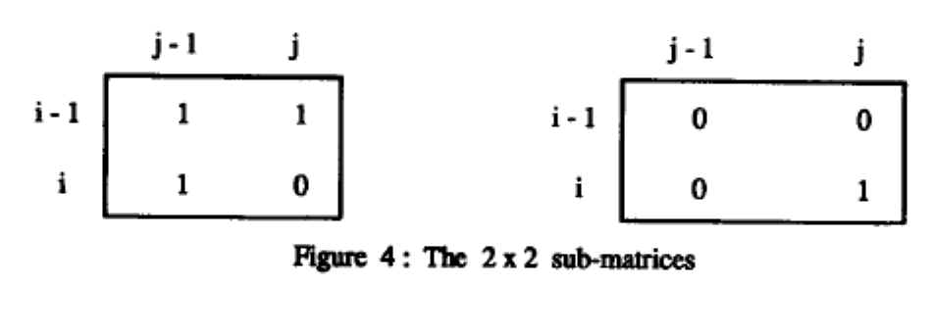
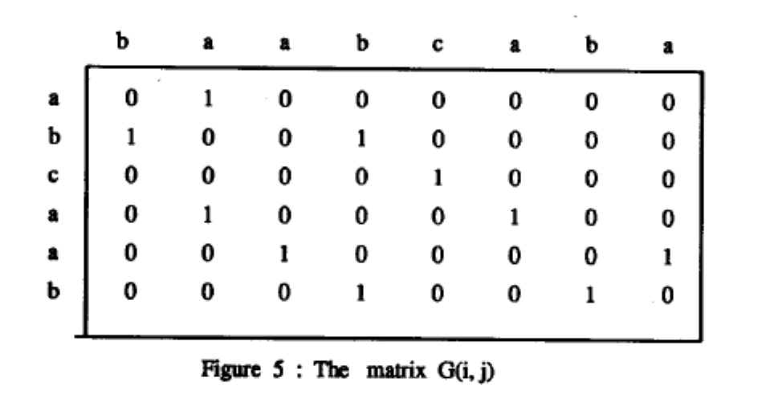
$$G(i,j)=1$$
if $((M(i,j)=1)(M(i,j−1)=M(i−1,j)=M(i−1,j−1)=0)=1$
or $((M(i,j)=0)(M(i,j−1)=M(i−1,j)=M(i−1,j−1)=1)=1$

L1=[(1,2),(2,1)] , L2=[(2,4),(4,2)] ,
L3=[(3,5),(5,3)] , L4=[(4,6),(6,4)] , L5=[(5,8),(6,7)]
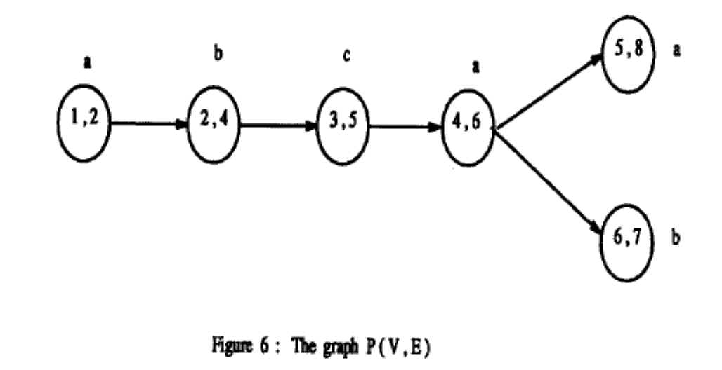
- Hardware Algorithms
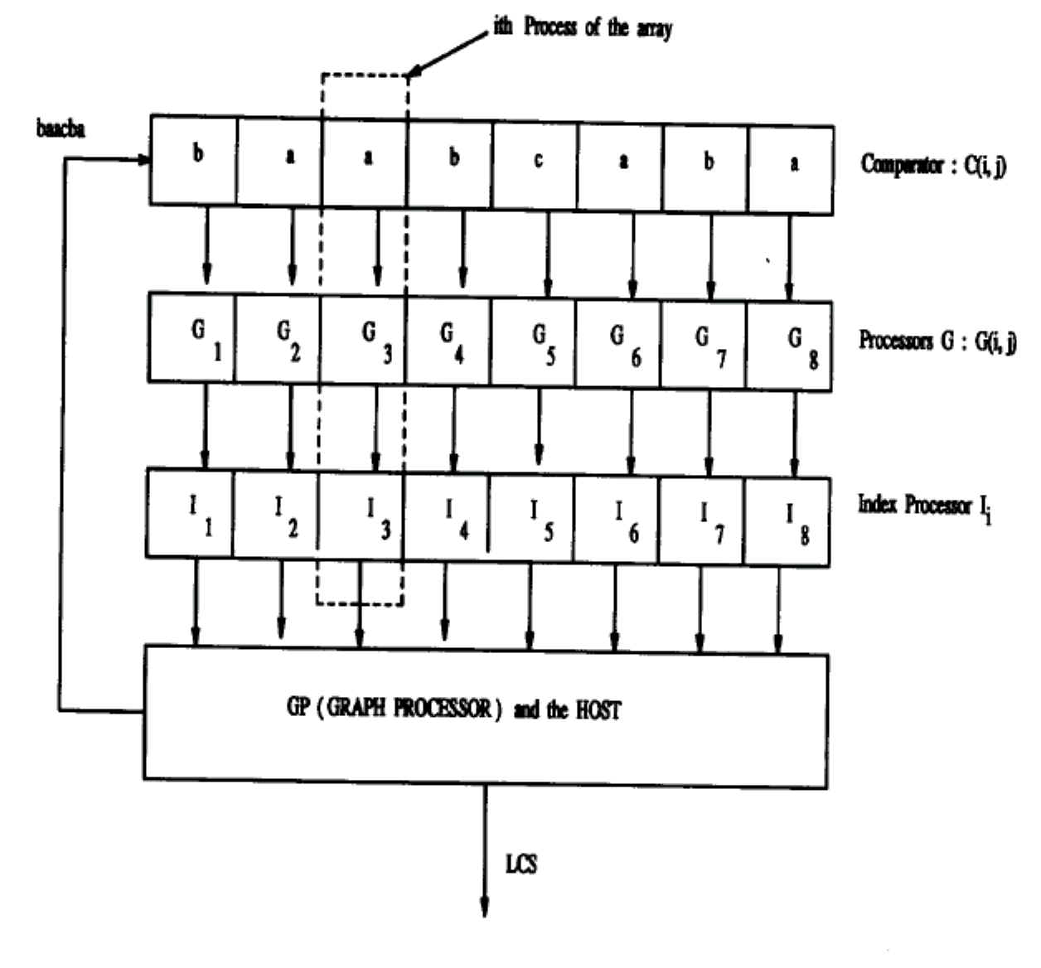
- Concluding Remarks

Created by : Kuen-Feng Huang

Date : Apr. 11, 2000

