Systolic-based parallel architecture for the longest common subsequences problem
Guillaume Luce, Jean Frederic Myoupo*
INTEGRATION, the VLSI journal 25 (1998) 53-70

Abstract
- Introduction
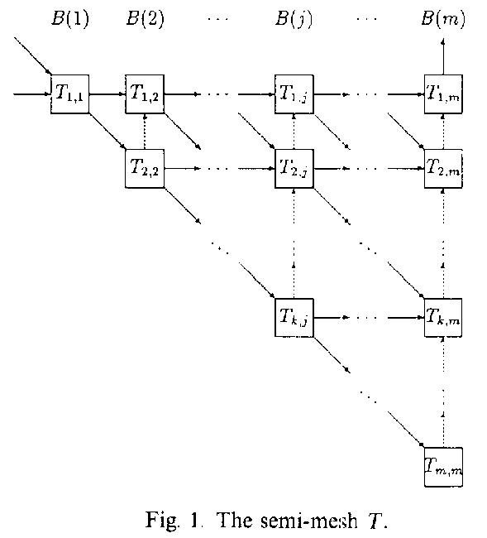
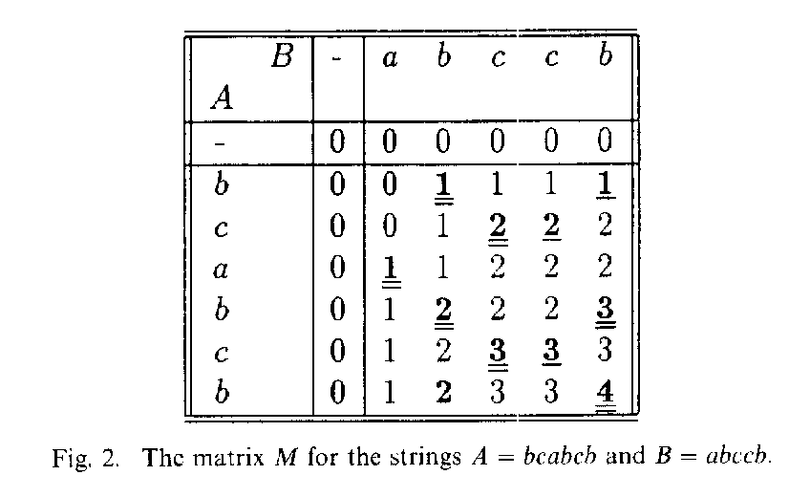
- Initialization Phase
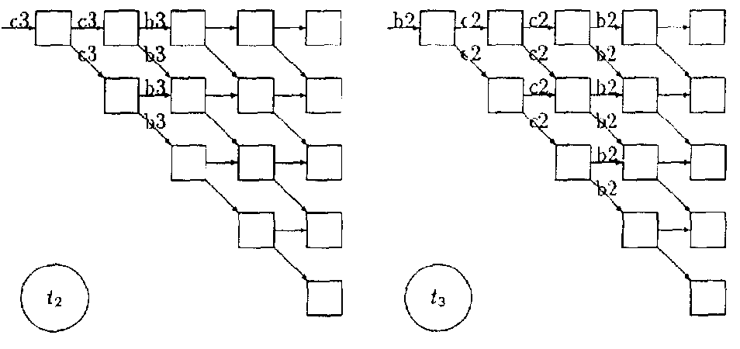
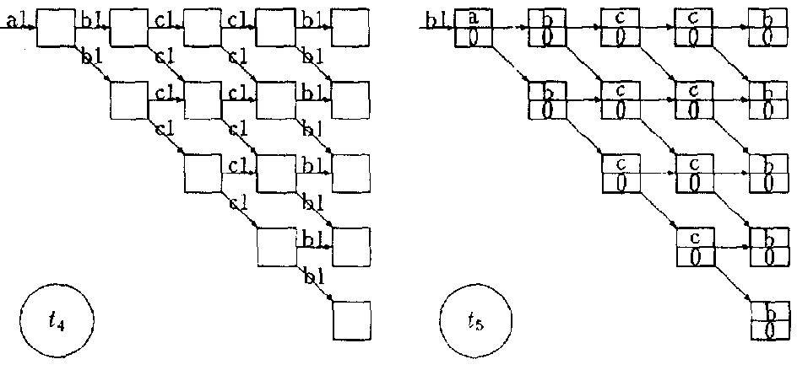
- Construction phase
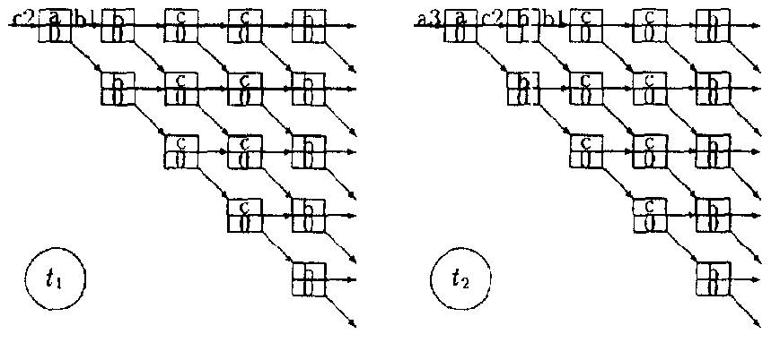

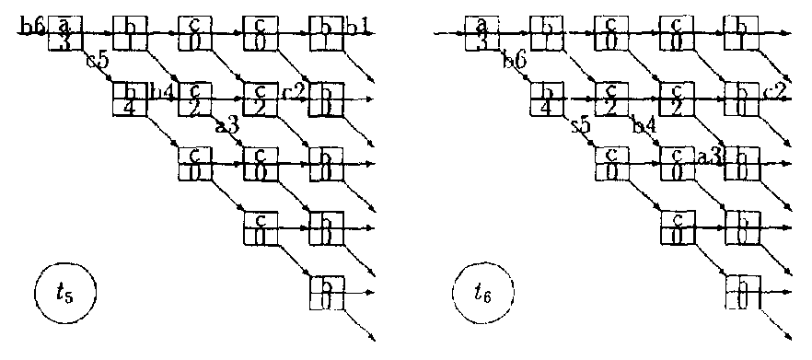
- Extract phase
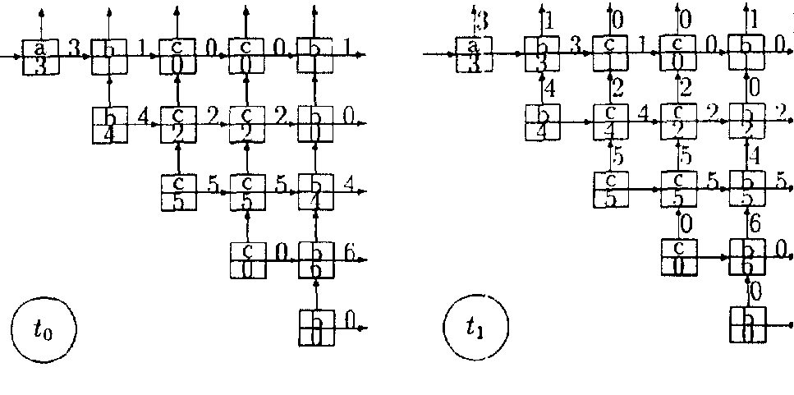
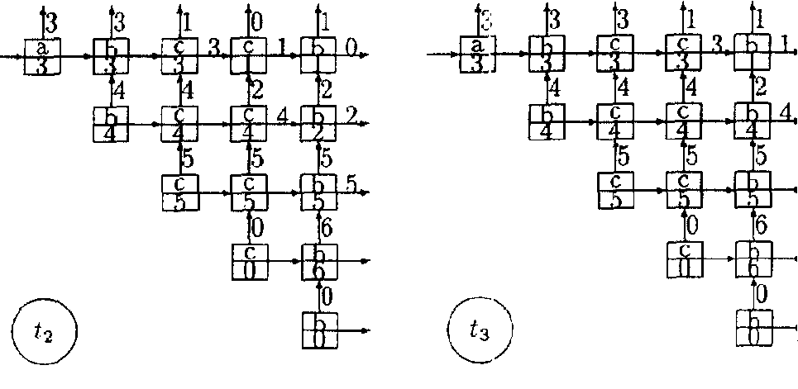

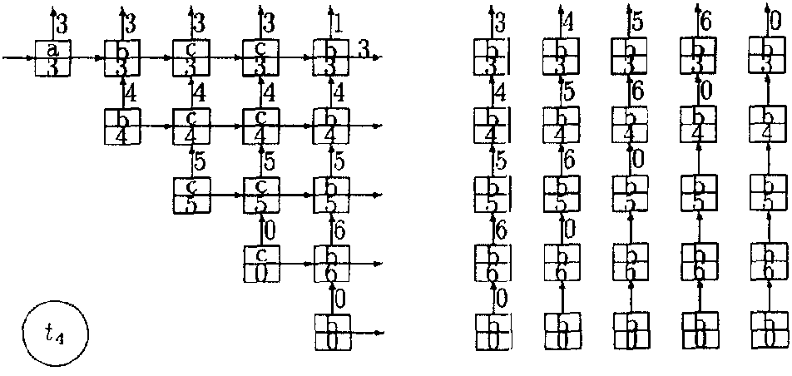

- Conclusion
Created by : Kuen-Feng Huang
Date : May. 3, 2000

