A Genetic Algorithm for the Steiner Problem in a Graph
Henrik Esbensen and Pinaki Mazumder
EDAC-ETC-EUROASIC, pp. 402-406, 1994
Abstract

- Background and Motivation

- Problem Definition
The Steiner Problem in a Graph (SPG)：Given a connected, undirected graph G =(V, E), a positive edge cost function c：E→R₊, and a subset W$⊆$V, compute a connected subgraph G' =(V', E') of G, such that W$⊆$V' and such that c(G') is minimal.
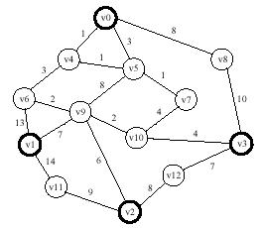

Distance Network Heuristic (DNH)
  - Construct the subgraph G₁ of D(G) induced by W.
  - Compute a MS_{P}T T₁ of G_{1.}
  - Construct from T₁ the subgraph G₂ of G by substituting each edge in T₁ by the corresponding shortest path in G.
  - Compute a MS_{P}T T₂ of G₂.
  - Construct T_{DNH} from T₂ by repeatedly deleting all vertices v$∈$V\W having deg(v)=1.

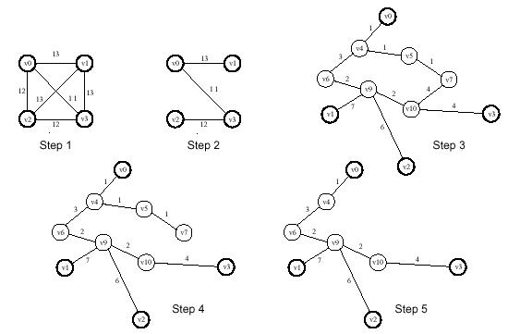

Genotype and Decoder

$$\left\{\left(π\left(0\right),i_{π\left(0\right)}\right),\left(π\left(1\right),i_{π\left(1\right)}\right),⋅⋅,\left(π\left(r−1\right),i_{π\left(r−1\right)}\right)\right\}$$

Definition of Fitness

Created by: Ing-Jer Liao
Date: March 19, 2002

