Ant Colony System：A Cooperative Learning Approach to Traveling Salesman Problem
Marco Dorigo and Luca Maria Gambardella
IEEE Transaction on Evolutionary Computation, Vol. 1, NO. 1, April 1997,
pp. 53-66
- Introduction
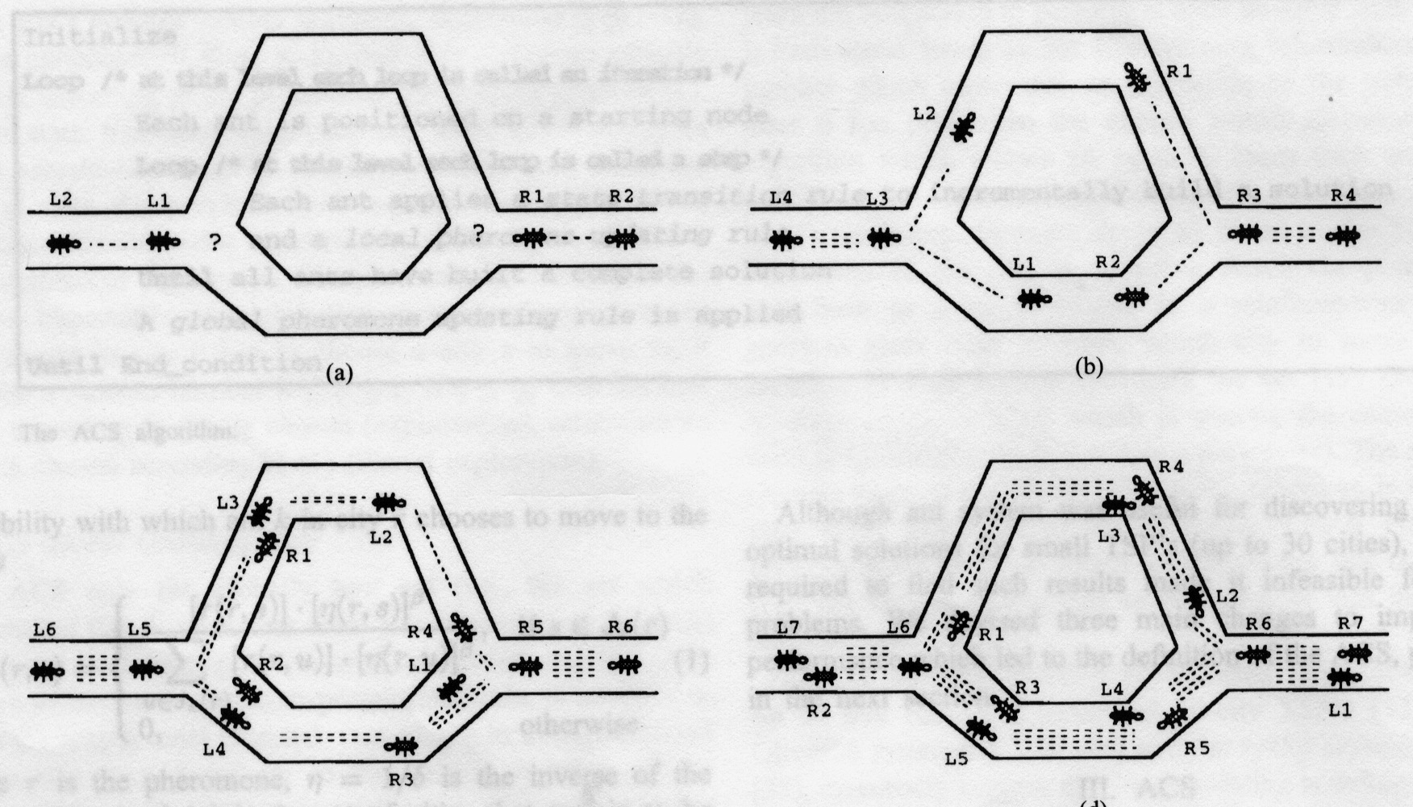
- Background
$$P_{k}(r,s)=\left\{\begin{matrix}\frac{[τ(r,s)]⋅[η(r,s)]^{β}}{\sum_{u∈J_{k}(r)}{[τ(r,s)]⋅[η(r,s)]^{β}}},\text{ if s }∈J_{k}(r) \\ 0\text{ otherwise}\end{matrix}\right.$$
$$τ(r,s)←(1−α)⋅τ(r,s)+\sum_{k=1}^{m}{{Δτ}_{k}(r,s)}$$

3. ACS
- ACS State Transition Rule
- ACS Global Updating Rule
- ACS Local Updating Rule
- ACS Parameter Settings

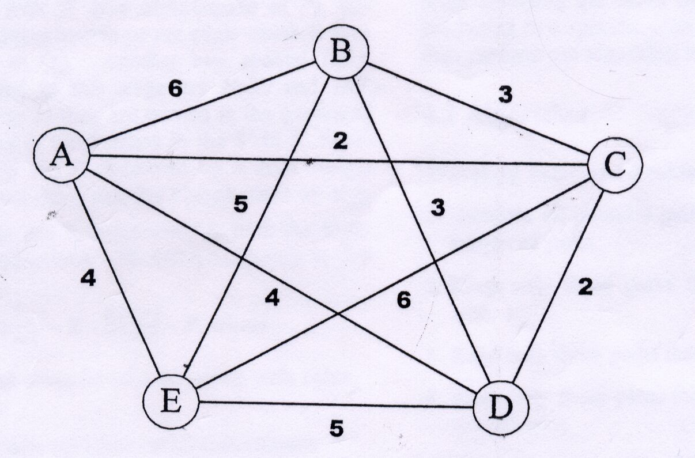
Created by: Ing-Jer Liao
Date: May 16, 2002

