Capturing Causality in Distributed Systems
Michel Raynal, Mukesh Singhal
IEEE Computer, pp. 49-56, February 1996

Abstract
This article presents a general framework of a system of logical clocks in distributed systems and discuss three methods—scalar, vector, and matrix—for implementing logical time in these systems. And it also presents three efficient implementations.

Introduction
A MODEL OF DISTRUBUTED EXECUTIONS
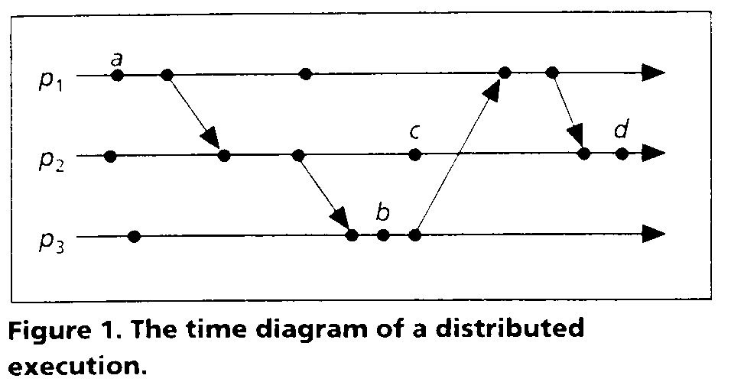

CONSISTENT:
- clock consistency:
e₁ → e₂ ⇒ C(e₁) < C(e₂)
- strongly consistent:
e₁ → e₂ ⇔ C(e₁) < C(e₂)

Implementing logical clocks

SCALAR TIME
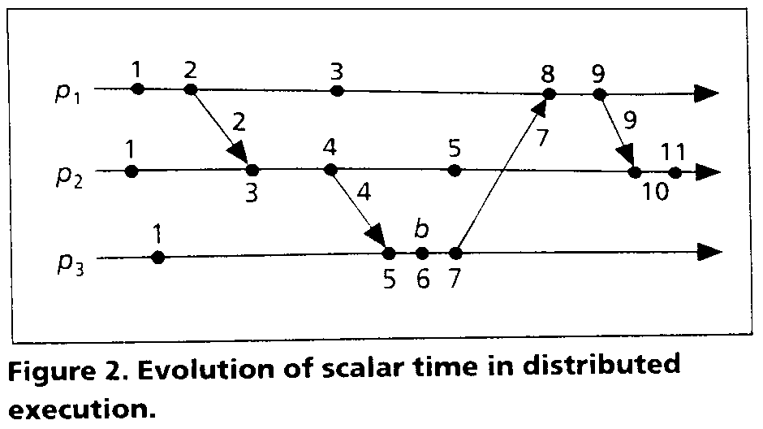
Rules R1 and R2 update the clocks as follows.
R1. Before executing an event (send, receive, or internal), p_{i} executes the following:
C_{i} := C_{i} + d (d > 0)
R2. Each message piggybacks the clock value of its sender at sending time. When p_{i} receives a message with the timestamp C_{msg}, it executes the following actions:
- C_{i} := max(C_{i} , C_{msg})
- Execute R1.
- Deliver the message.
However, the system of scalar clocks is not strongly consistent.

- VECTOR TIME
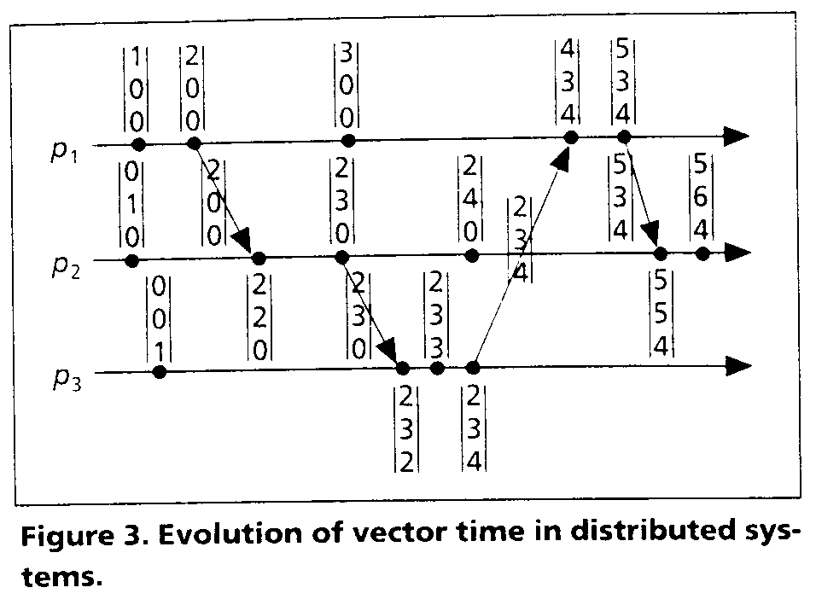
The process p_{i} use the following R1 and R2 to update its clock.
R1. Before executing an event, p_{i} updates its local logical time as follows:
vt_{i}[i] := vt_{i}[i] + d (d > 0)
R2. Each sender process piggybacks a message m with its vector clock value at sending time. Upon receiving such a message (m, vt), p_{i} executes the following sequence of actions:
1. Update its logical global time as follows:
1 ≤ k ≤ n: vt_{i}[k] := max(vt_{i}[k], vt[k])
2. Execute R1.
3. Deliver the message m.
The system of vector clocks is strongly consistent.

- MATRIX TIME
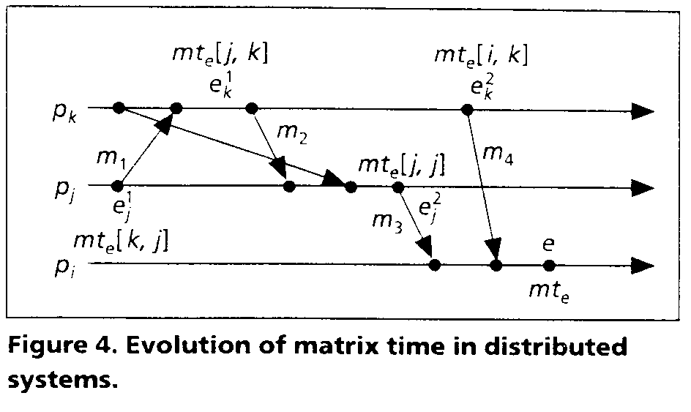
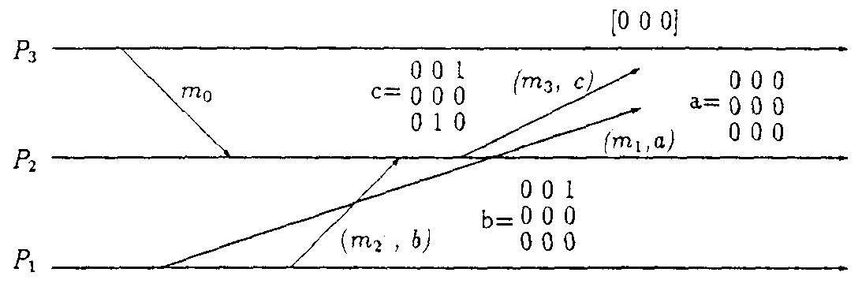
Process p_{i} use the following R1 and R2 to update its clock.
R1. Before executing an event, p_{i} updates its local logical time as follows:
mt_{i}[i, i] := mt_{i}[i, i] + d (d > 0)
R2. Each message m is piggybacked with the matrix time mt. When p_{i} receives such a message (m, mt) from p_{i}, p_{i} executes the following sequence of actions:
1. Update its logical global time as follows:
1 ≤ k ≤ n: mt_{i}[i, k] := max(mt_{i}[i,k], mt[j, k])
1 ≤ k, l ≤ n: mt_{i}[k, l] := max(mt_{i}[k, l], mt[k, l])
2. Execute R1.
- Deliver message m.

EFFICIENT IMPLEMENTATIONS
- Singhal-Kshemkalyani’s differential technique
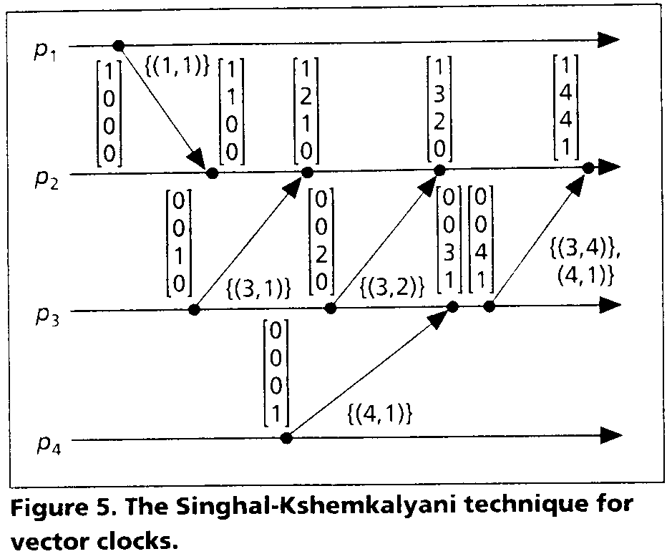

- Fowler-Zwaenepoel’s direct-dependency technique
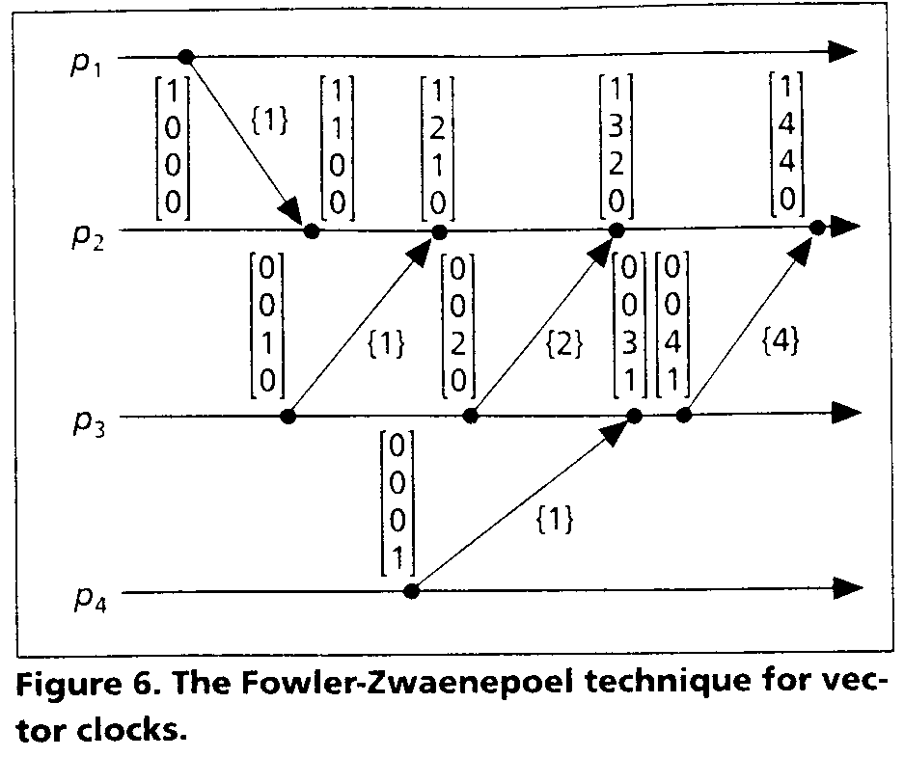

- Jard-Jourdan’s adaptive technique
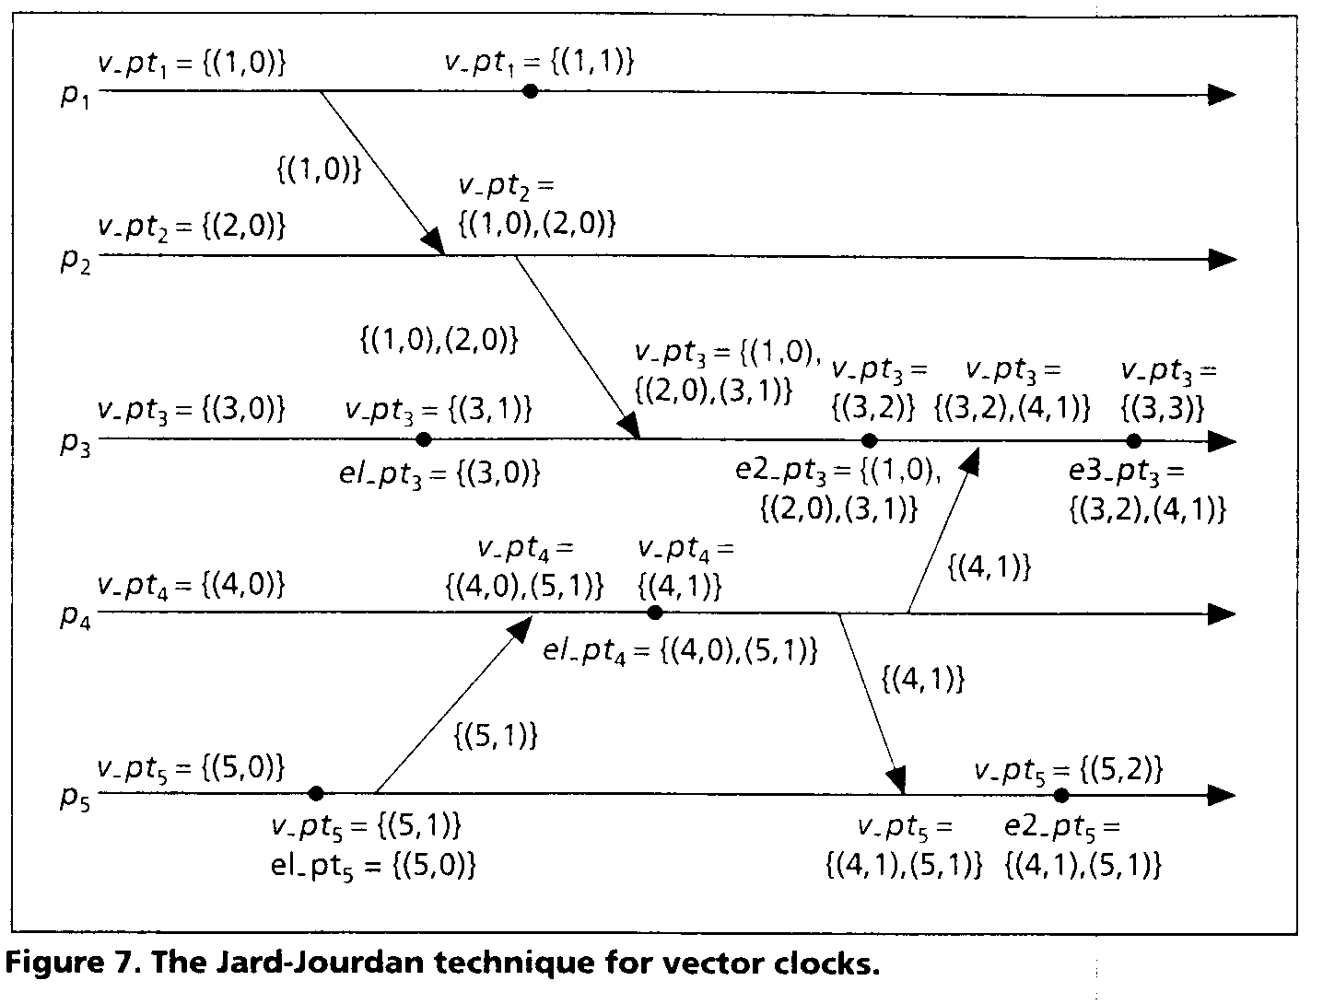

Conclusion
We have presented a general framework of logical clocks in distribution systems and have discussed three systems of logical clocks: scalar, vector, and matrix. We also discussed three efficient implementations of vector clocks; similar techniques can be used to efficiently implement matrix clocks.

