TIGR Assembler: A New Tool for Assembling Large Shotgun Sequencing Projects
Granger G. Sutton, Owen White, Mark D. Adams and Anthony R. Lerlavage
Abstract
A new approach to assembling large, random shotgun sequencing projects has been developed. The TIGR Assembler overcomes several major obstacles to assembling such projects: the large number of pairwise comparisons required, the presence of repeat regions, chimeras introduced in the cloning process, and sequencing errors. TIGR Assembler has been used to assemble the complete 1.8 Mbp Haemophilus influenzae (Fleischmann, et al, 1995) and 0.58 Mbp Micoplasma genitalium (Fraser, et al, 1995) genomes.
Introduction
There are many assembly algorithms available, including XBAP (Gleeson, et al., 1991), AutoAssembler (Applied Biosystems, Foster City, CA.), GCG (Dolz, 1994), and several others (reviewed in Miller,et al., 1994). However, they typically do not perform well on reconstructions of an order of magnitude larger scale. A more recent assembly program, FALCON (Gryan, 1994), uses a fast pairwise comparison method similar to TIGR Assembler and can handle very large assembly projects.
The basic steps in the TIGR Assembler algorithm are outlined below:
- Perform pairwise fragment comparisons for the entire dataset to generate a list of potential fragment overlaps.
- Use the distribution of the number of potential overlaps for each fragment to label fragments as repeat or non-repeat.
- Start with a non-repeat fragment as the initial assembly seed or a repeat fragment if no non-repeat fragment is left; quit if no fragment remain.
- Use potential overlap list to attempt merges between the current assembly and non-repeat fragments.
- When no potential overlaps with non-repeat fragments remain for the current assembly, increase the stringency of the match criteria and enforce clone length constraints when attempting to merge with repeat fragments.
- If due to a merge with a repeat fragment, a non-repeat fragment is added to the potential overlap list go to step 4.
- When there are no fragments left on the current potential overlap list, output information about the current assembly and go to step3.
Pairwise Comparison
TIGR Assembler compares every fragment to every other fragment to find potential pairwise overlaps. The pairwise comparison of all n fragment involves approximately n² comparison. For the H. influenzae genome project there were approximately 25,000 fragments requiring 625,000,000 pairwise comparisons.
Merging Fragments with Assemblies
There are four elements of the match criteria: minimum length of overlap, minimum similarity in the overlap region as a percentage of the best possible score, maximum length of overhang, and maximum number of local errors.
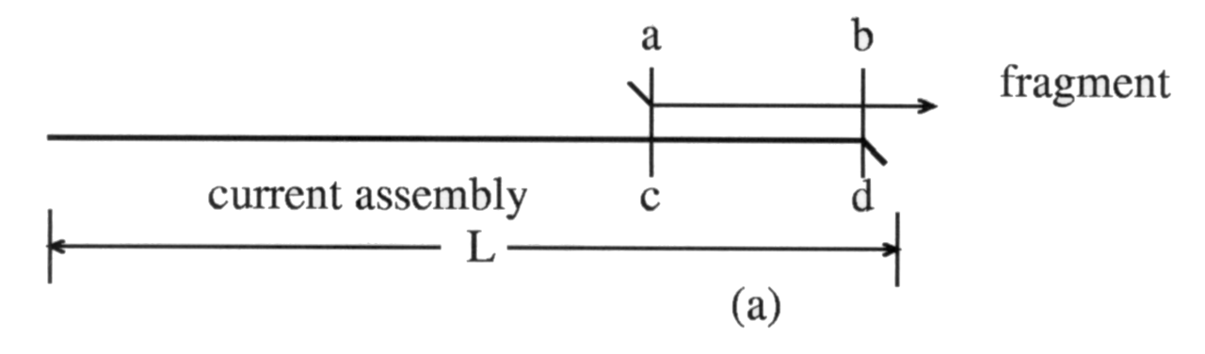
Building a Consensus Sequence
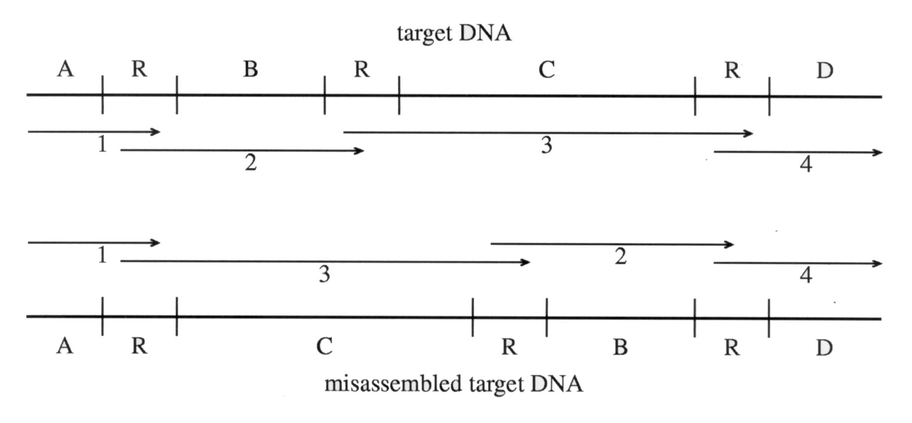
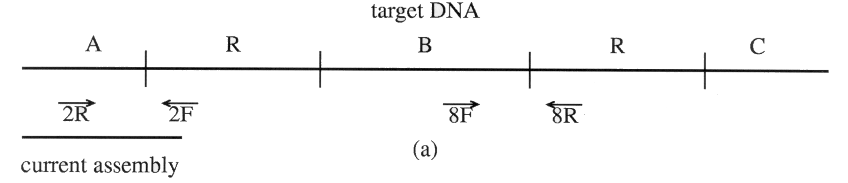
Repeat Regions
A very important task for TIGR Assembler is identifying repeat regions in the target DNA because these regions have the most potential to cause mis-assembly of the target. A repeat region is a contiguous piece of DNA that has a very high similarity to another piece of DNA in the target.
Concurrent Assemblies
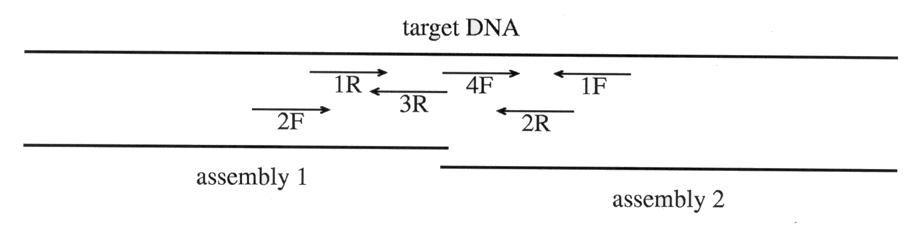
Clone mate information can be used to detect chimeric clone.
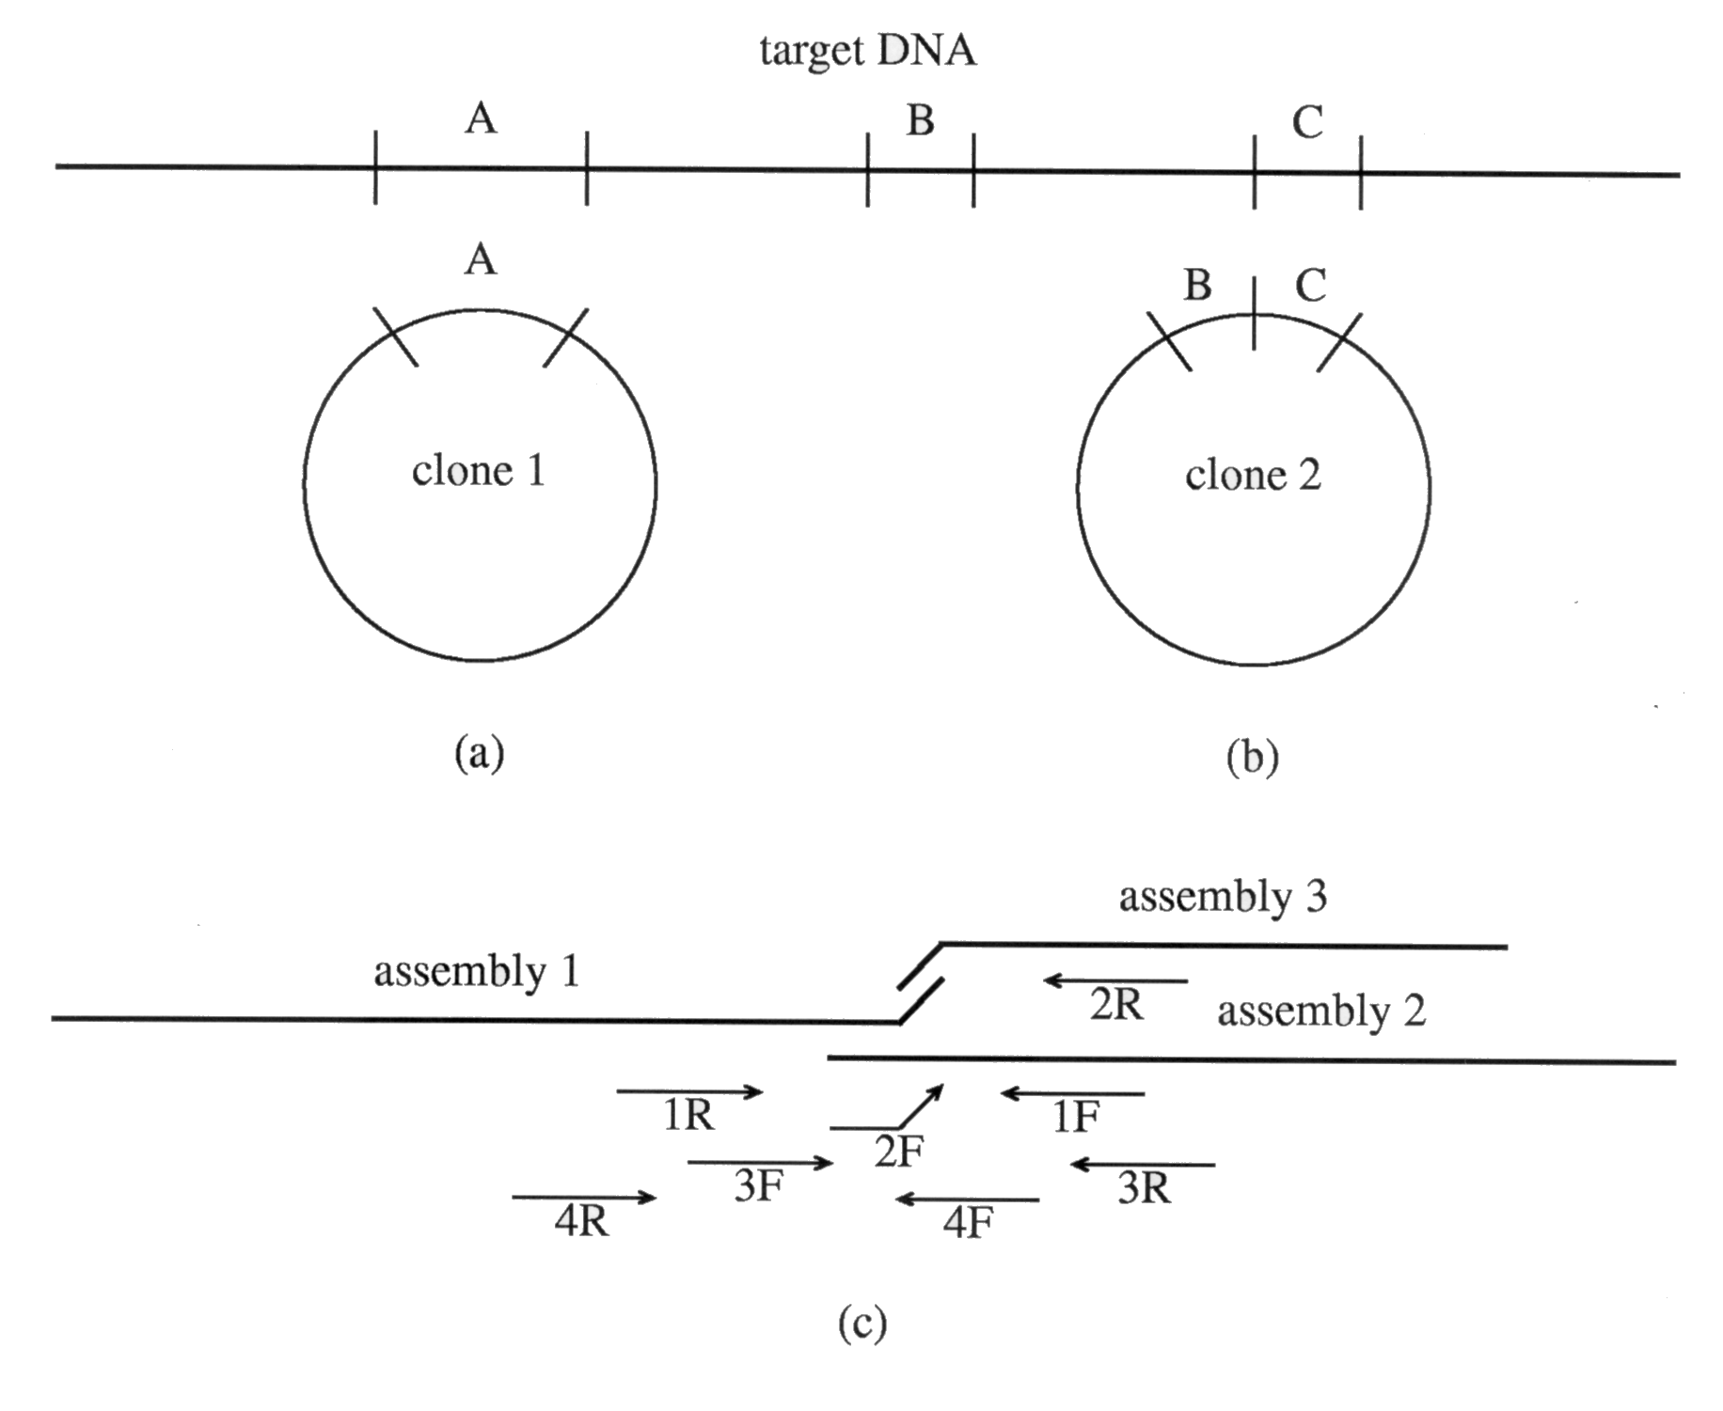
Optimal Clone Length
The choice of optimal clone size is dependent upon the total size of the target DNA and the size of typical repeats. For the shorter clones, inserts of up to 5 Kbp should work very well.
Implementation Details
For the H. influenzae genome, approximately 25,000 fragments were assembled with n=10 in 30 hours on a Sun SPARCstation 5 with 40 Mbytes of RAM and 100 Mbytes of virtual memory. We have also assembled 186,000 ESTs into 20,000 assemblies (with 39,000 non-overlapping ESTs remaining) on a single processor of a Sun SPARCCenter 2000 with 512 Mbytes of RAM in 7days.

Created by: Lih-Ching Lin
Date: Nov. 16, 1998

