A Cost and Speed Model for k-ary n-Cube Wormhole Routers
Andrew A. Chien
IEEE TRANSACTIONS ON PARALLEL AND DISTRIBUTED SYSTEMS, VOL. 9, NO. 2 FEBRUARY 1998

Abstract
In this paper, we describe a parameterized cost model for router performance, characterized by two numbers: router delay and flow control time. Grounding the cost model in a 0.8 micron gate array technology, we used it to compare a number of proposed routing algorithms.

Introduction
The evaluation of advanced routing features must be based on both of costs and benefits. To date, adaptive routers have generally been evaluated on the basis of the achieved network throughput (channel utilization), ignoring the effects of implementation complexity.
In this paper, we develop a parametric cost and speed model for a family of routers based on canonical architecture. This model allows us to evaluate and compare the cost of various routing features in hardware resources as well as achievable router speed.

Background
MIT Alewife, Standford DASH, and Tera Computer’s TERA machine. All of these machines use topologies from the family of k-ary n-cubes. That is, in systems with k^{n} nodes, the networks have n dimensions and k nodes along each dimension. All of the routers considered in this paper can be used in k-ary n-cube topologies.

Basic router functions
A wormhole router must perform several basic functions: switching, routing, flow control, multiplexing physical channels, inter-chip signaling, and clock recovery. A basic wormhole router architecture is shown in Fig. 1.
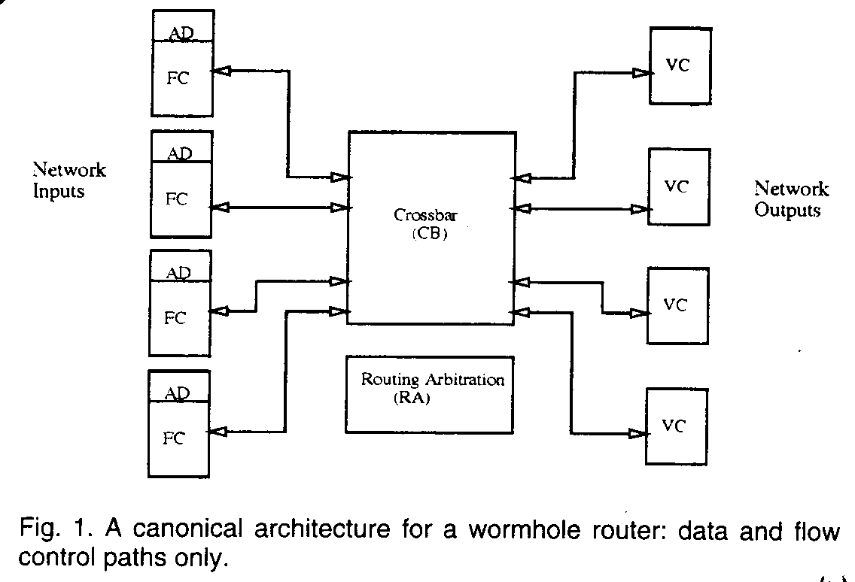
The essential components of the router and their functionality are described below.
- Crossbar (CB) provided the basic switching function from router inputs to outputs.
- Flow Control units (FC) perform flow control between routers, stopping a message in place if necessary.
- Address Decoders (AD) examine the packet header and generate the set of possible routes, based on the routing algorithm.
- Routing Arbitration logic (RA) chooses the path and connects and disconnects the input with an appropriate output based on the routing algorithm and network status information.
- Virtual Channel controllers (VC) multiplex the physical channels, providing a set of virtual channels that can progress independently.

A parametric cost model
Here, we describe each router module and its implementation complexity. Formulas for gate count complexity and delay can be found in Fig. 2.
- Crossbar: While there are many possible implementations, most routers use a tree of gates, or selector, foe each output. Thus crossbar size grows as the product of the number of inputs and outputs, and the delay grows logarithmically due to the depth of the selection trees.
- Flow Control unit: Major contributors to flow control unit delay are the timing constrains and delays for latches and flip-flops.
- Address Decoder: The address encoding can affect the complexity of this operation, but the encoding is typically chosen to minimize such effects. We model the decoder delay as constant.
- Routing Arbitration logic: In the worst case, packets might arrive on all inputs simultaneously, requiring circuits with at least logarithmic depth in the number of inputs. We assume simple arbitration algorithms implemented with log depth circuits..
- Virtual Channel controller: VC delay increases logarithmically in the number of virtual channels due to arbitration for the physical channel and the gates required route the latch output to the channel.

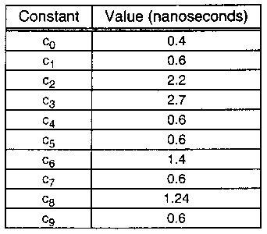
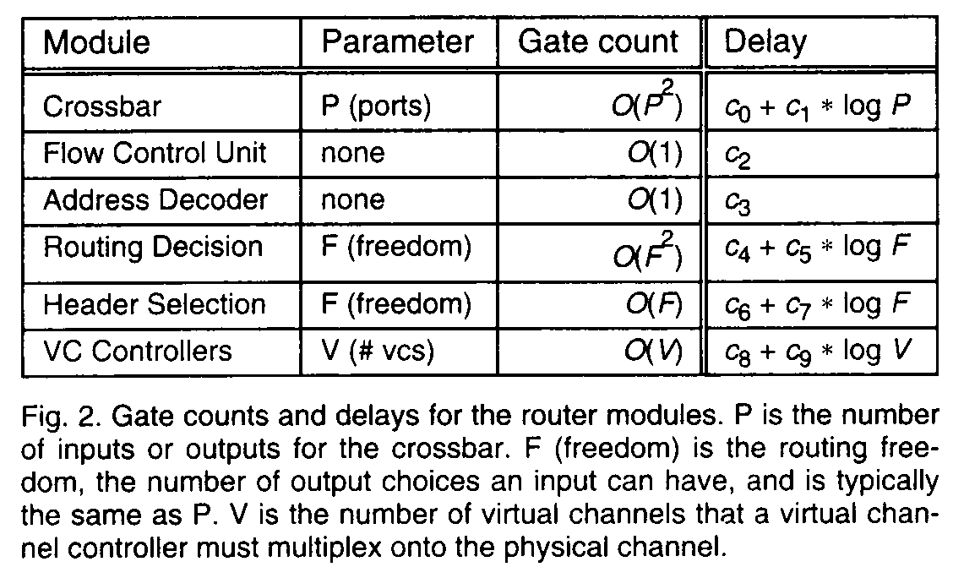

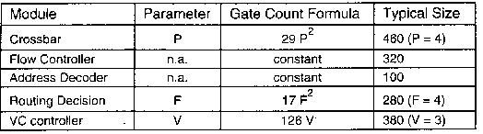

Application
Dimension-Order Router
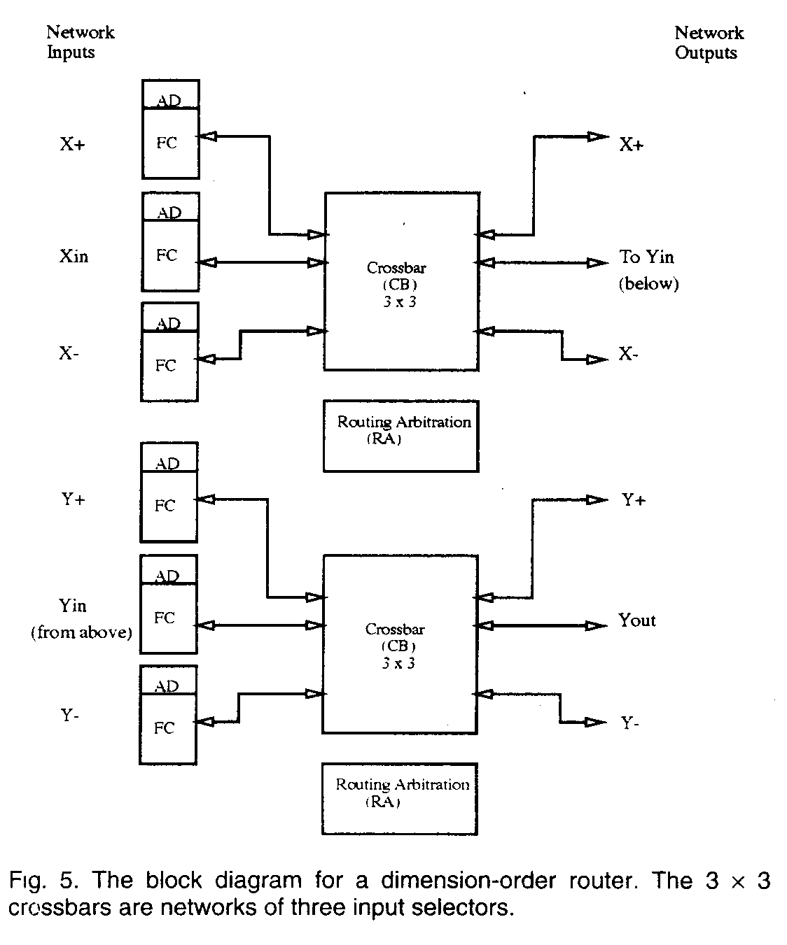
The setup delay in a dimension-order router involves decoding the address (and updating the header), a trivial routing decision whether to continue in the current dimension or proceed to the next, connecting to the crossbar, and sending data through the crossbar.
The equation for setup delay can
T_{DimOrder} = T_{AD} + T_{ARB} + T_{CB}
which, based on our parameterized model and the fact that the dimension order router requires P = 3, F = 3, and V = 0, gives
T_{DimOrder} = c₃ + c₄ + c₅ * log F + c₀ + c₁ * log P,
T_{DimOrder} = c₃ + c₄ + c₅ * log 3 + c₀ + c₁ * log 3,
Performing a flow control operation in a dimension-order router requires delay though the crossbar and flow controller. The flow control delay can be written as shown:
T_{fc-DimOrder} = T_{FC} + T_{CB},
T_{fc-DimOrder} = c₂ + c₀ + c₁ * log P.
Planar-Adaptive Router
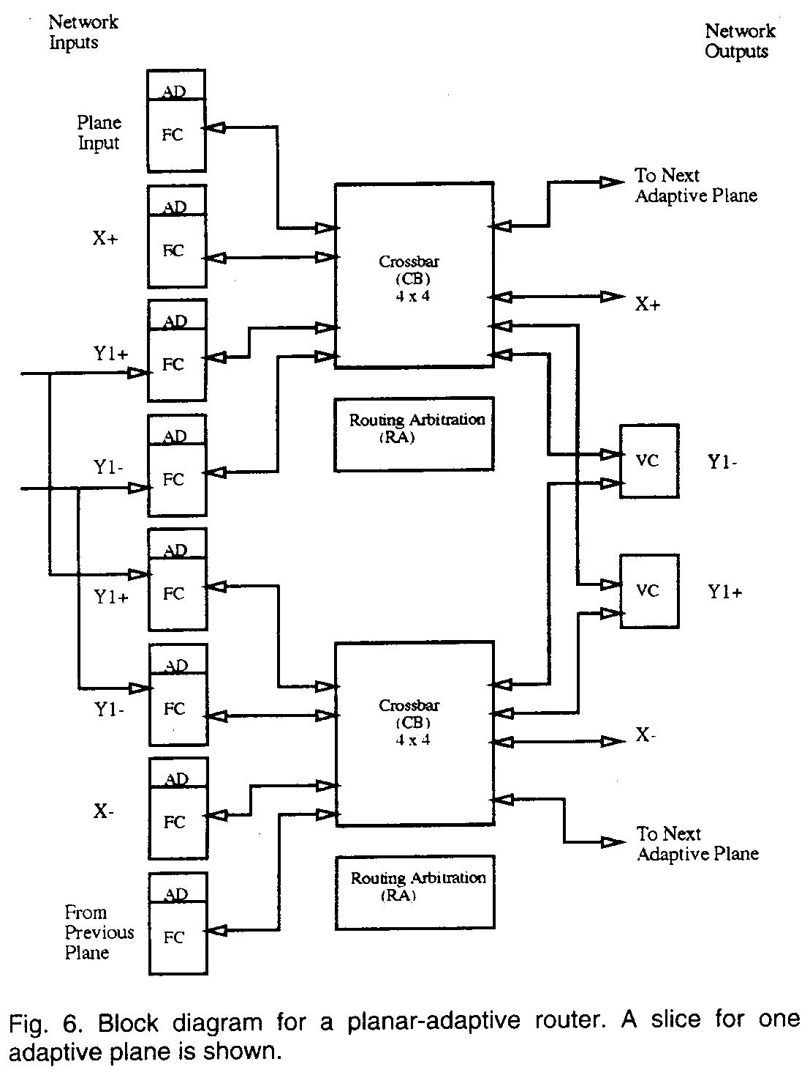
The router setup delay for the PAR is:
T_{PAR} = T_{AD} + T_{ARB} + T_{SEL} + T_{CB} + T_{VC}
Plugging in the expressions from Fig. 2,
T_{PAR} = c₃ + c₄ + c₅ * log F + c₆ + c₇ * log F + c₀ + c₁ * log P + c₈ + c₉ * log V,
using P = 4, F = 4, and V = 3 based on the deadlock-freedom requirements gives:
T_{PAR} = c₃ + c₄ + c₅ * 2 + c₆ + c₇ * 2 + c₀ + c₁ * 2 + c₈ + c₉ * log 3,
The flow control latency in the planar-adaptive router can be written as follows:
T_{fc-PAR} = T_{FC} + T_{CB} + T_{VC}
T_{fc-PAR} = c₂ + c₀ + c₁ * log P + c₈ + c₉ * log V
Plugging in the values P = 4 and V = 3 for the PAR gives
T_{fc-PAR} = c₂ + c₀ + c₁ * 2 + c₈ + c₉ * log 3

The Turn Model
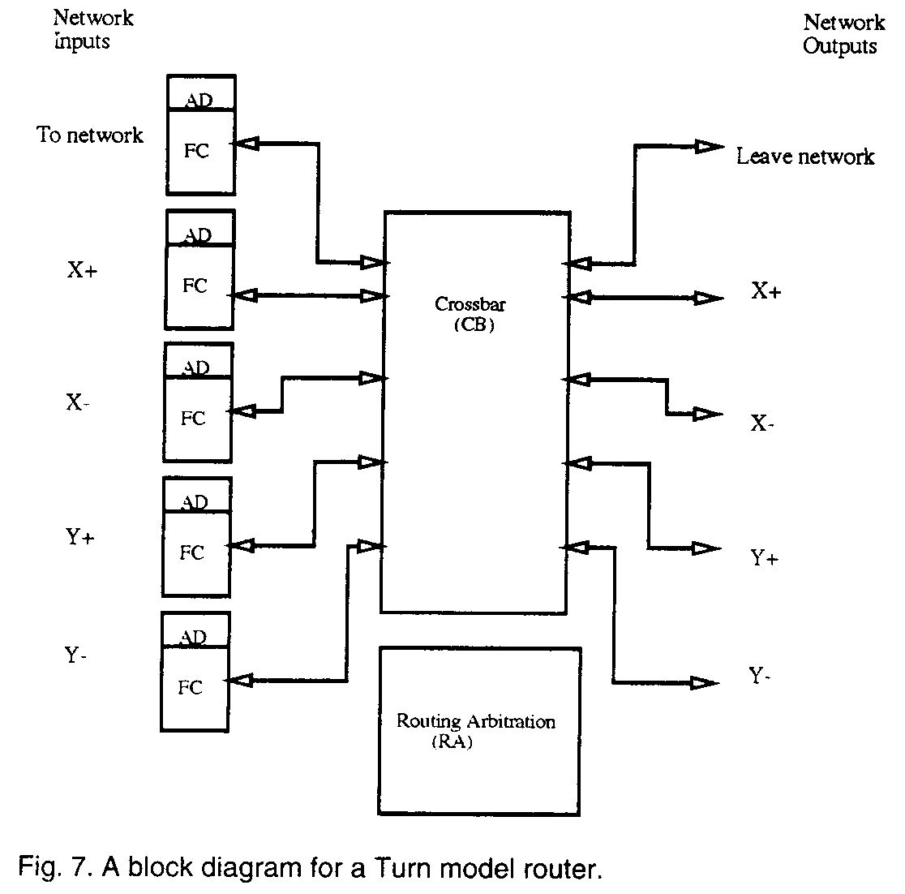
The setup delay involves the address decoder, the router decision logic, the header section logic and, finally, the crossbar delay.
The setup delay for a two-dimensional turn-model router can be written as follows:
T_{Turn} = T_{AD} + T_{ARB} + T_{SEL} + T_{CB}
T_{Turn} = c₃ + c₄ + c₅ * log F + c₆ + c₇ * log F + c₀ + c₁ * log P,
where, in this case, F = P = 2D + 1. D is the network dimension.
T_{Turn} = c₃ + c₄ + c₅ * log(2D + 1) + c₆ + c₇ * log(2D + 1) + c₀ + c₁ * log(2D + 1)
The flow control delay for the Turn Model router has similar structure to that of the dimension order router, though the crossbar is a little larger. It can be written as follows:
T_{fc-Turn} = T_{FC} + T_{CB}
which, plugging in our parameterized model, gives
T_{fc-Turn} = c₂ + c₀ + c₁ * log P
T_{Dfc-Turn} = c₂ + c₀ + c₁ * log(2D + 1)

*-Channels Router
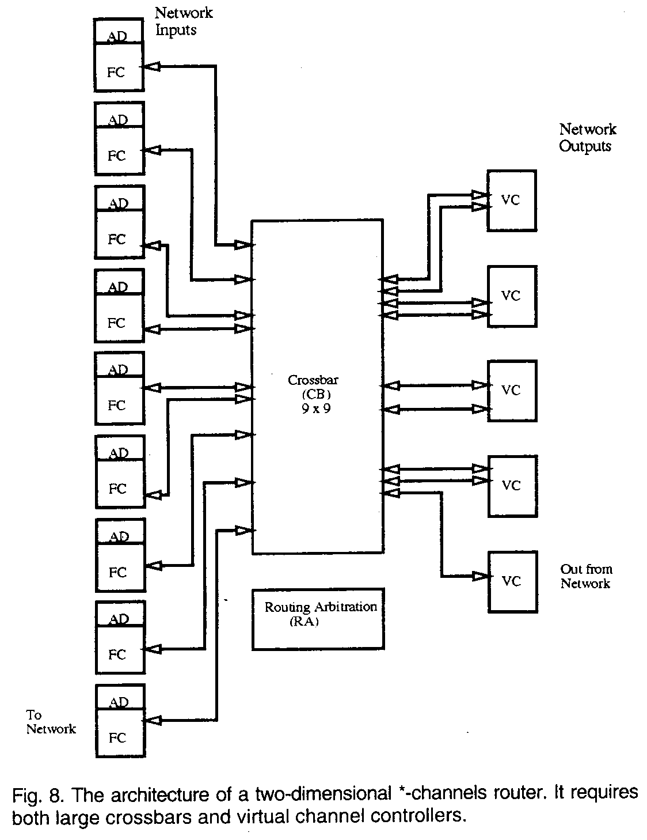
The setup latency for the best case, assuming no stalling for a previous packet, can be written as follows:
T_{SC} = T_{AD} + T_{ARB} + T_{SEL} + T_{CB} + T_{VC}
Plugging in the expressions from Fig. 3,
T_{SC} = c₃ + c₄ + c₅ * log F + c₆ + c₇ * log F + c₀ + c₁ * log P + c₈ + c₉ * log V,
For two-dimensional network router, P = 9, F = 9, and V = 2 gives:
T_{SC} = c₃ + c₄ + c₅ * log9 + c₆ + c₇ * log9 + c₀ + c₁ * log9 + c₈ + c₉
The flow control latency:
T_{fc-SC} = T_{FC} + T_{CB} + T_{VC}
T_{fc-SC} = c₂ + c₀ + c₁ * log P + c₈ + c₉ * log V
Which, for two dimensions, the values P = 4D +1 = 9 and V = 2, gives
T_{fc-SC} = c₂ + c₀ + c₁ * log9 + c₈ + c₉

Router Gate Counts
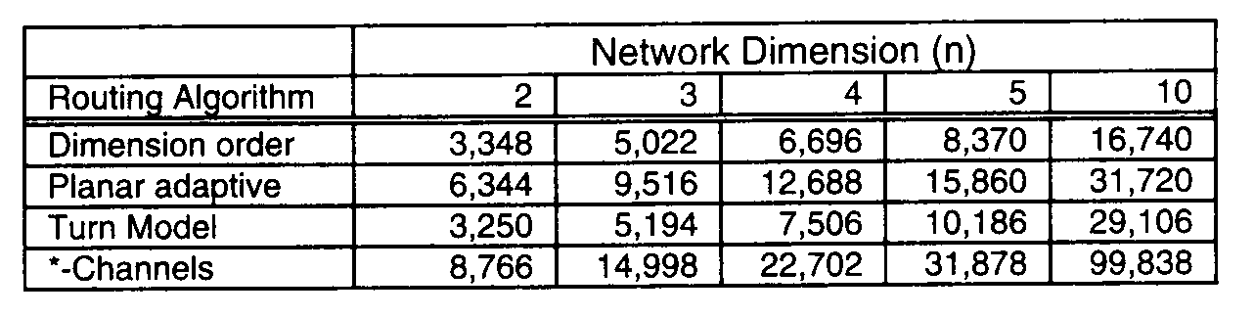
Discussion and Analysis
Overall Delays:
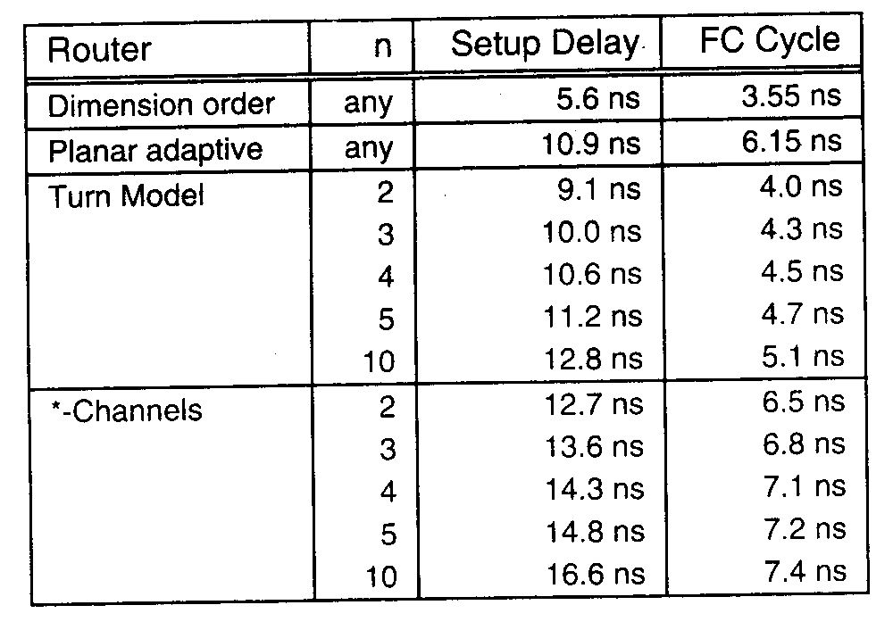
Setup Delay Constituents
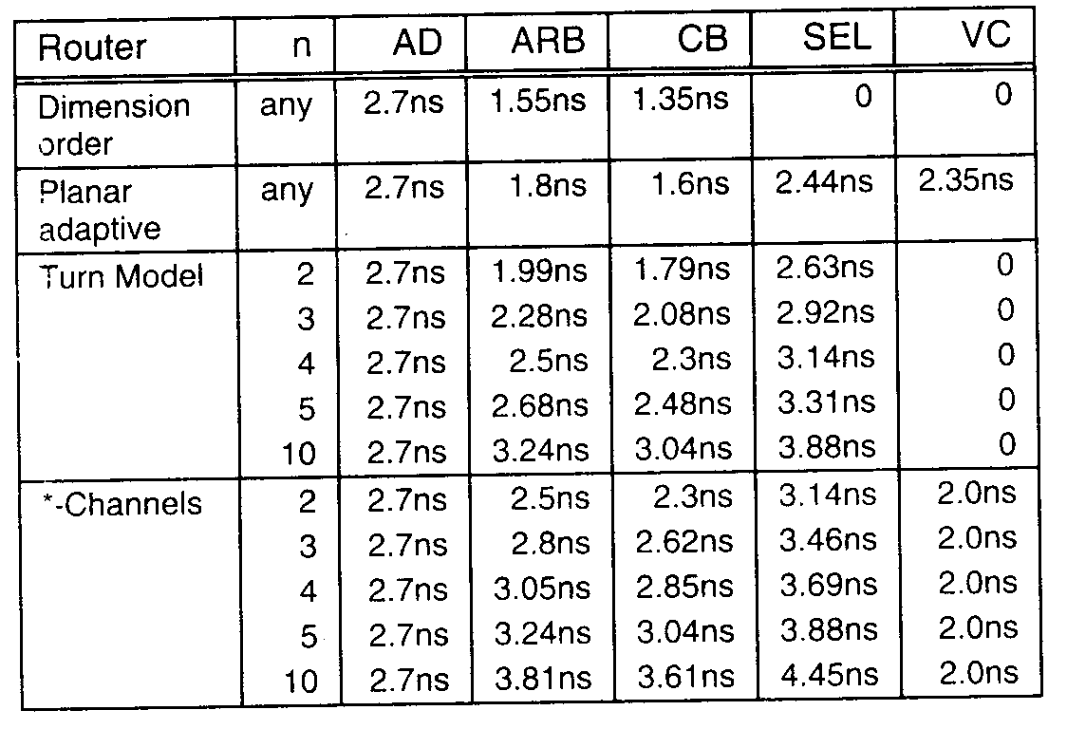
Cycle Time Constituents
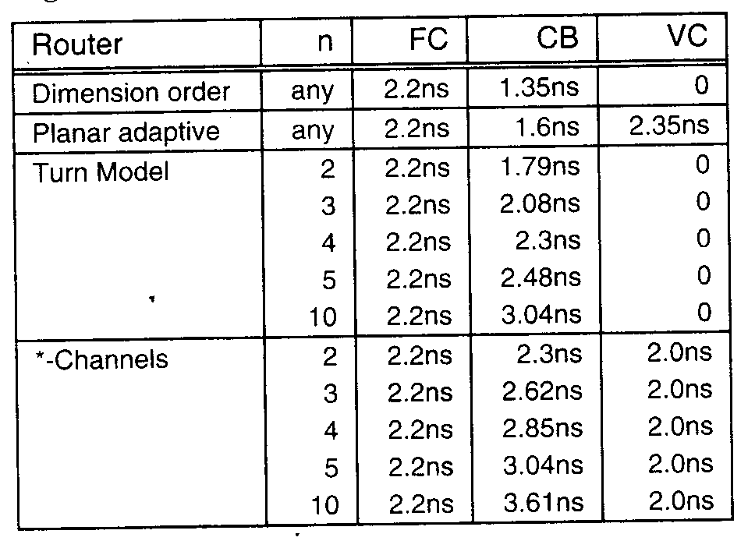
Summary and Conclusion
We have developed a parametric cost model for wormhole routers. This model captures the cost and achievable speed of basic routing functions, providing a basis for calibrating simulation studies, and complexity of a wide variety of routing algorithms.
The purpose of developing a parametric speed model is to compare the cost and complexity of a variety of routing algorithms. Based on our experience, we can make a number of observations on how a routing algorithm affects the complexity and speed of its implementation.

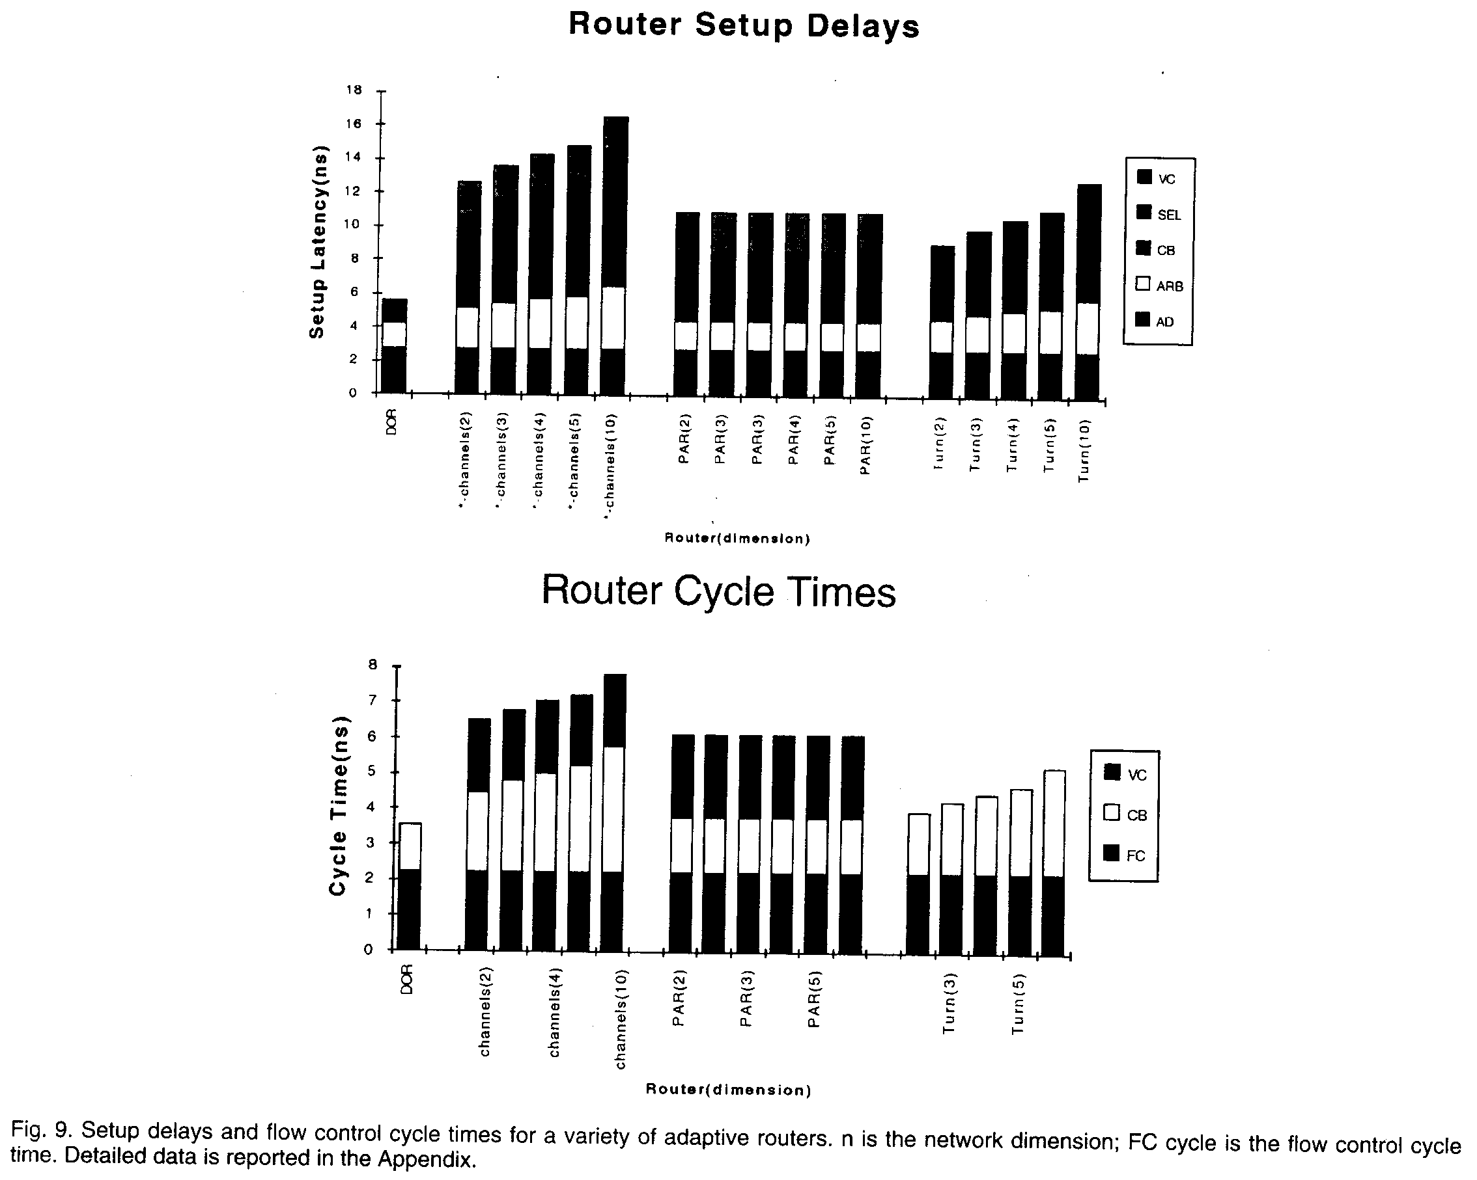

Created by: Lih-Ching Lin
Date: Jun. 3, 1998

