Maximum Agreement Subtree in a Set of Evolutionary Trees – Metrics and Efficient Algorithm
Amihood Amir, Dmitry Keselman
SIAM Journal on Computing, Vol. 26, No. 6, pp.1656-1669, 1997
Introduction
There are two ways one can go about handling different evolutionary trees for the same species. One may try to construct a consensus tree that is “close” to all given trees. Another direction is extracting the maximum set of species about whom we are confident.
Maximum Isomorphic Agreement Subtree

Definition: Let T₁,…,T_{k} be S-labeled trees. A maximum weighted agreement subtree of T₁,…,T_{k} (MWT(T₁,…,T_{k})) is a maximum set S` ⊆ S such that for all s and t ⊆ S’ the distance between s and t is the same in all trees T₁,…,T_{k}. We will also refer to the problem of finding the maximum weighted agreement subtree as the MWT problem.
In MWT, if all weights are uniformly 1, we call this the maximum isomorphic agreement subtree problem (MIT).

Algorithm Outline

for r = s₁ to s_{n} do
root all tree at r.
find MIT(T₁,…,T_{k})
choose the largest of all n rooted MIT’s

end Algorithm

Recursive Algorithm for Finding Rooted MIT

- prune all trees to include only the labels that are equidistant to r in all trees.
- construct i disjoint thread intersections {S₁,…, S_{i}} of S – {r} (i ≦ n – 1).
construct i tuples {T₁₁,…,T_{k1}},…,{T_{1i},…,T_{ki}}.
recursively find the MIT of each of the i tuples.
- choose MIT(T₁,…,T_{k}) as the largest of {MIT(T₁₁,…,T_{k1}),…, MIT(T_{1i},…,T_{ki})}
Maximum Homeomorphic Agreement Subtree

Definition: Let T be an S-labeled tree and let S` ⊆ S. H(T, S`) is the minimal homeomophic subtree of T containing exactly the leaves labeled by S`.
Let T₁,…,T_{k} be S-labeled trees. A maximum homeomorphic agreement subtree of T₁,…,T_{k} (MHT(T₁,…,T_{k})) is a maximum cardinality set S` ⊆ S such that H(T₁, S`) = H(T₂, S`) = … = H(T_{k}, S`). We will also refer to the problem of finding a maximum homemorphic agreement subtree as the MHT problem.

Algorithm for Rooted MHT ( degree bounded by d tree )

- Construct all n^{d-1} maximal decomposable sets.
- Order the maximal decomposable sets by the subset relation.
- The base subsets (those that have no maximal decomposable subsets) are sets A = A₁∪…∪A_{d-1} where each of the A_{i}’s, i = 1, …, d-1, is a singleton set {a_{i}}. MHT(A) is A.
For subsequent maximal decomposable subsets, construct the MHT by the relation MHT(A) = MHT(A₁)∪MHT(A₂)∪…∪MHT(A_{d-1}). For any maximal decomposable A_{i}, we have already computed the MHT. If any of the A_{i} is not maximal, its MHT is that of its largest maximal decomposable subset. MHT(S) is MHT(A), where A is the largest maximal decomposable subset of S.
Maximum Interval Agreement Subtree
Definition: Let T₁,…,T_{k} be S-labeled trees. Assume that every edge is labeled by a pair of numbers [a, b], where a < b. We call such trees S-labeled interval labeled tree. An instantiation T’ of an S-labeled interval labeled tree T is an S-labeled weighted tree where all nodes and edges of T’ are equal to the nodes and edges of T and where every edge of T’ is labeled by a number in the interval label of that edge in T.

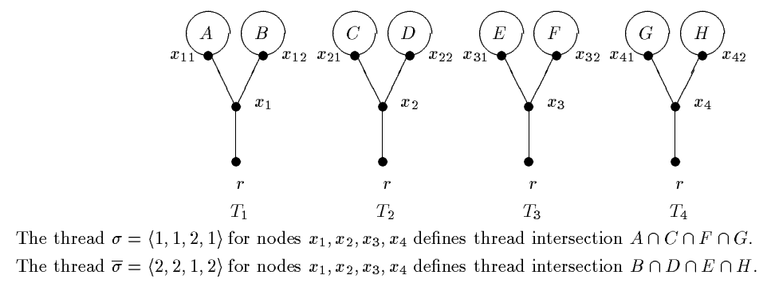
Example of thread intersection

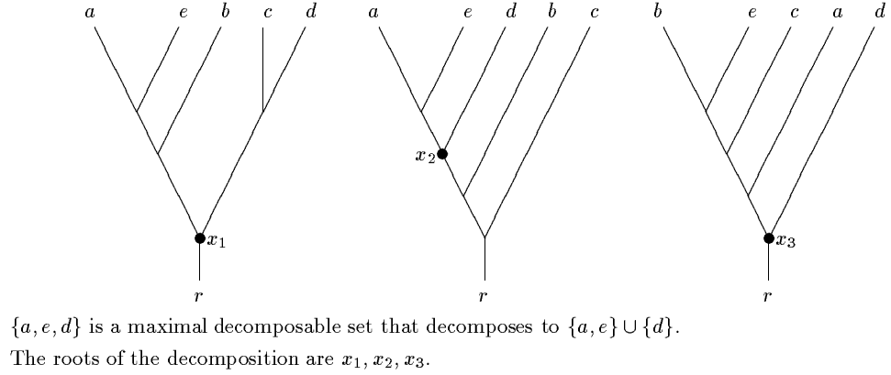
Example of a decomposable set

Created by : Chao-Li Peng
Date : Nov. 27, 2001

