Fast Sorting by Reversal
Piotr Berman and Sridhar Hannenhalli
Combinatorial Pattern Matching, CPM'96 to appear

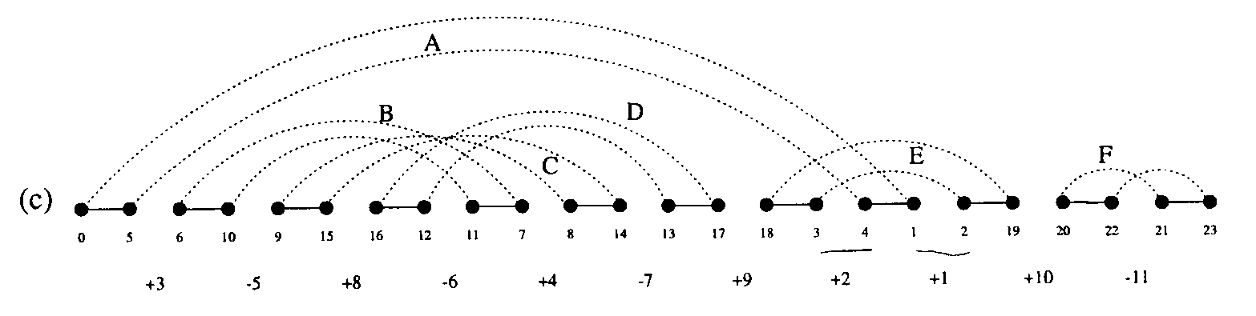
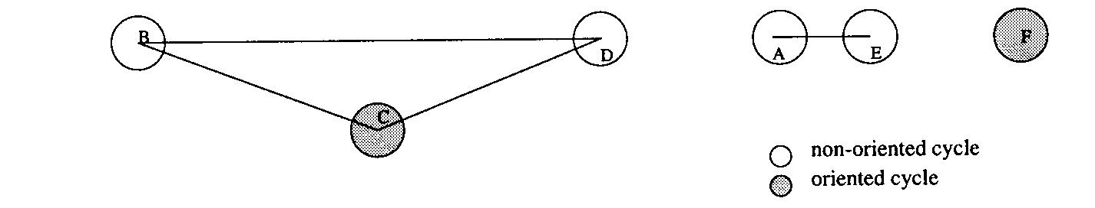

Algorithm for computing connected components of an interleaving graph of a permutation.
