★★★☆☆
題組：Problem Set Archive with Online Judge
題號：10080: Gopher II
解題者：周安
解題日期：2023年4月20日
題意：
有n隻地鼠，m個地洞，每隻地鼠在s秒內跑進地洞即安全，不受掠食者威脅，一個地洞只能有一隻地鼠，地鼠跑步速度為v，計算在s秒後，不安全的地鼠有幾隻?
題意範例：
輸入:
2 2 5 10 ➔n m s v
1.0 1.0 ➔第一隻地鼠座標(x,y)
2.0 2.0 ➔第二隻地鼠座標(x,y)
100.0 100.0 ➔第一個地洞座標(x,y)
20.0 20.0 ➔第二個地洞座標(x,y)
輸出:
1 ➔ 一隻地鼠會被吃掉
解法：
使用二分圖找出最大匹配，有兩個集合(G,H)，一個代表地鼠，一個代表地洞，集合內元素不會相連，集合G、H之間元素(i , j)的連線與否，取決於此地鼠(i)能否在時間內跑到此地洞(j)。
把二分圖加入源點s、匯點t，把題型變成網路流找最大流量，流出s的量必等於流進t的量，網路流中的edge是有方向性，此題s到每個地鼠的最大容量皆是1，每個地鼠到t的最大容量皆是1，地鼠與地洞集合之間的連線最大容量也是1。
依照Ford–Fulkerson method實作:
1. 創建residual graph來複製原始的graph中的容量。 residual graph存的容量是路徑中的每一段路減掉最小流量後的graph。
2. 在residual graph中找從s到t的最短路徑用BFS，採用BFS時，此方法可稱為Edmonds–Karp算法。
3. 找到路徑後，找到路徑中的最小流量，並把路徑各段的剩餘容量減掉最小流量，得到新的residual graph。
同時，需要新增一個反向的路徑，容量為剛剛減去的最小流量，以免一開始走錯路可以反悔。
重複做第2步。
4. 如果第2步找不到可行路徑，代表我們已經找到最大流量了，最大流量是從s流出的總容量或是流進t的總流量。
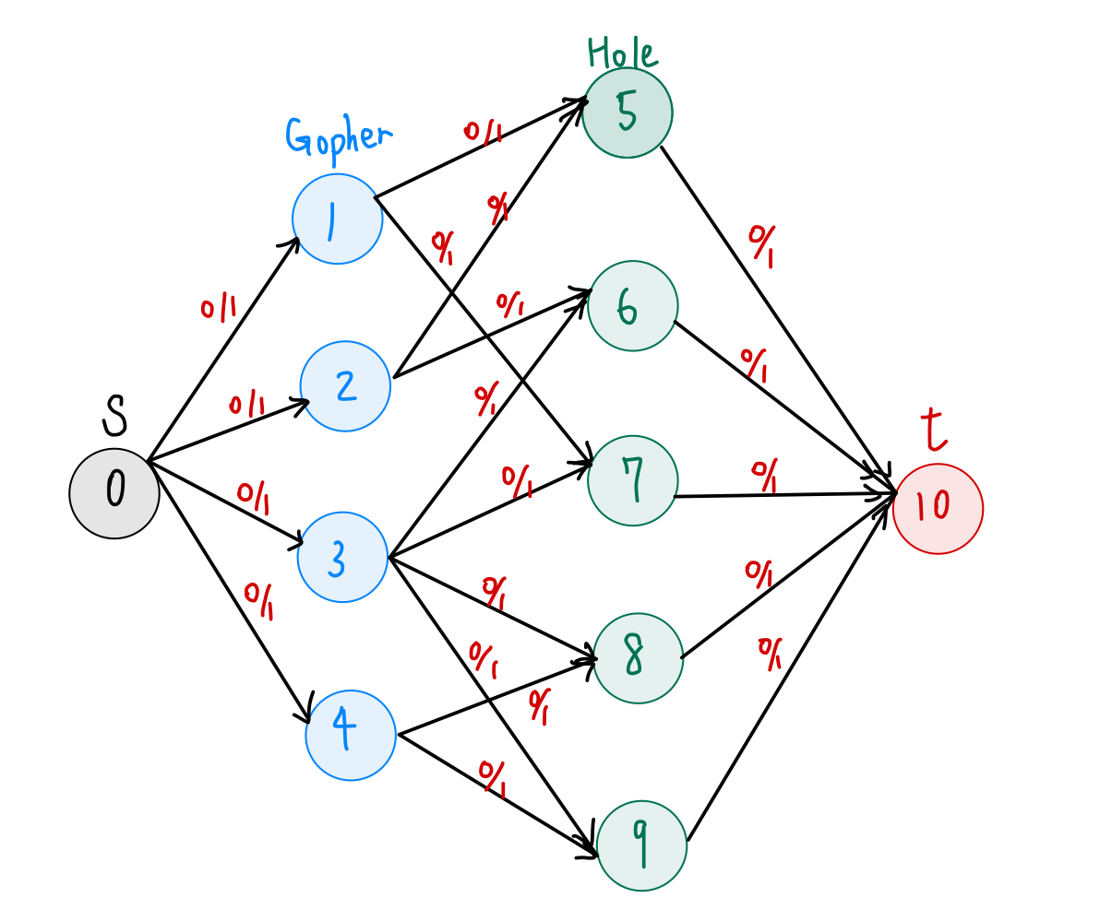
Graph示意圖:
此圖有4隻地鼠、5個地洞，新增源點s、匯點t，每條edge(0/1)代表初始流量為0，容量為1。
解法範例：
無。
討論：
無。
程式：
//UVA 10080
//bipartie graph
//Ford Fulkerson algorithm
#include <iostream>
#include <limits.h>
#include <queue>
#include <string.h>
#include <cmath>
using namespace std;
/* Returns true if there is a path from source 's' to sink
't' in residual graph. Also fills parent[] to store the
path */
//find the shortest path from s to t in residual graph
bool bfs(int **rGraph, int s, int t, int parent[], int row_col)
{
// Create a visited array and mark all vertices as not visited
bool *visited=new bool[row_col];
//initialize
for(int i = 0 ; i < row_col; i++)
{
visited[i] = false;
}
// Create a queue, enqueue source vertex and mark source
// vertex as visited
queue<int> q;
q.push(s);
visited[s] = true;
parent[s] = -1;

// Standard BFS Loop
while (!q.empty()) {
int u = q.front();
q.pop();

for (int v = 0; v < row_col; v++) {
if (visited[v] == false && rGraph[u][v] > 0) {
// If we find a connection to the sink node,
// then there is no point in BFS anymore We
// just have to set its parent and can return
// true
if (v == t) {//reach 't'
parent[v] = u;
//release memory
delete [] visited;
return true;//found a path from 's' to 't'
}
q.push(v);
parent[v] = u;
visited[v] = true;
}
}
}
// We didn't reach sink in BFS starting from source, so return false
//release memory
delete [] visited;
return false;
}

// Returns the maximum flow from s to t in the given graph
int fordFulkerson(int **graph, int s, int t, int row_col)
{
int u, v;//index

//Residual graph
int **rGraph = new int*[row_col];
for(int i = 0; i < row_col; i++)
{
rGraph[i] = new int[row_col];
}
//copy at first
for (u = 0; u < row_col; u++)
for (v = 0; v < row_col; v++)
rGraph[u][v] = graph[u][v];

int *parent = new int[row_col];// store path
//"parent[v] = u" means "u -> v"

int max_flow = 0; //There is no flow initially

// Augment the flow while there is path from s to t
while (bfs(rGraph, s, t, parent,row_col)) {
// Find minimum residual capacity of the edges along
// the path filled by BFS. Or we can say find the
// maximum flow through the path found.
int path_flow = INT_MAX;
for (v = t; v != s; v = parent[v]) {
u = parent[v];
path_flow = min(path_flow, rGraph[u][v]);//find the minimum flow in paths
}

// update residual capacities of the edges and
// reverse edges along the path
for (v = t; v != s; v = parent[v]) {
u = parent[v];
rGraph[u][v] -= path_flow;//every flow in paths subtract the path_flow
rGraph[v][u] += path_flow;//add the reverse flow
}

// Add path flow to overall flow
max_flow += path_flow;
}

//release memory
delete [] parent;

for(int i = 0; i < row_col; i++)
{
delete [] rGraph[i];
}
delete [] rGraph;

return max_flow;//overall flow
}
/////////////////////////////////////////////
class Gopher//gopher's coordinate
{
public:
float x;
float y;
};
class Hole//hole's coordinate
{
public:
float x;
float y;
};

float distance(Gopher p1, Hole p2)
{
return sqrt((p1.x-p2.x)*(p1.x-p2.x) + (p1.y-p2.y)*(p1.y-p2.y));
}
//////////////////////////////////////////

int main()
{
int n,m,s,v;//num_gopher, num_hole, second, velocity
while(cin >> n >> m >> s >> v)
{
Gopher temp1;
Hole temp2;
vector<Gopher> vG;//all gopher
vector<Hole> vH;//all hole
int vertice = n+m+2;//num_vertice, including all gophers, holes, and s,t in network flow.

int **matrix = new int*[vertice];//an 2D dynamic array(vertice*vertice)
for(int i = 0; i < vertice; i++)
{
matrix[i] = new int[vertice];
}

//record coordinates
for(int i = 0; i < n; i++)
{
cin >> temp1.x >> temp1.y;
vG.push_back(temp1);
}
for(int i = 0; i < m; i++)
{
cin >> temp2.x >> temp2.y;
vH.push_back(temp2);
}

//make the network flow graph(matrix[][])
//initialize
for(int i = 0; i < vertice; i++)
{
for(int j = 0; j < vertice; j++)
{
matrix[i][j] = 0;
}
}
//The flow capacity from s to every gopher is 1.
for(int i = 1 ; i <= n; i++)
{
matrix[0][i] = 1;
}
//The flow capacity from every hole to t is 1.
for(int i = n + 1 ; i <= m + n; i++)
{
matrix[i][m+n+1] = 1;
}
//connect the edges between gophers and holes
for(int i = 1; i <= n; i++)
{
for(int j = n+1; j <= m+n; j++)
{
if(distance(vG[i-1], vH[j-n-1]) <= float(s*v))//safe distance
{
matrix[i][j] = 1;
}
else
{
matrix[i][j] = 0;
}
}
}
//Ans
cout << n - fordFulkerson(matrix, 0, n+m+1,vertice) << endl;
//release memory
for(int i = 0; i < vertice; i++)
{
delete [] matrix[i];
}
delete [] matrix;
}
return 0;
}

