資料結構Chapter 7勾選之習題
7.1.3.
Compare the efficiency of searching an ordered sequential table of size n and searching an unordered table of the same size for the key key:
(a) If no record with key key is present
(b) If one record with key key is present and only one is sought
(c) If more than one record with key key is present and it is desired to find only the first one
(d) If more than one record with key key is present and it is desired to find them all

7.1.11.
The following search algorithm on a sorted array is known as the Fibonaccian search because of its use of Fibonacci numbers. (For a definition of Fibonacci numbers and the fib function, see Section 3.1.)

for (j = 1; fib(j) < n; j++)
;
mid = n - fib(j - 2) + 1;
f1 = fib(j - 2);
f2 = fib(j - 3);
while (key != k(mid))
if (mid < 0 key > k(mid)) {
if (f1 == 1)
return(-1);
mid += f2;
f1 -= f2;
f2 -= f1;
}
else {
if (f2 == 0)
return(-1);
mid -= f2;
t = f1 - f2;
f1 = f2;
f2 = t;
} /* end if */
return(mid);

Explain how this algorithm works. Compare the number of key comparisons with the number used by the binary search. Modify the initial portion of this algorithm so that it computes the Fibonacci numbers efficiently, rather than looking them up in a table or computing each anew.

7.2.1
Write an efficient insertion algorithm for a binary search tree to insert a new record whose key is known not to exist in the tree.

7.2.5
Write an algorithm to delete a node from a binary tree that replaces the node with its inorder predecessor, rather than its inorder successor.

7.2.10
Show that the Fibonacci tree of order h+1 (see Exercise 5.3.5) is a height-balanced tree of height h and has fewer nodes than does any other height balanced tree of height h.

7.3.11
Write a search-and-insert algorithm and C routine for the digital search forest of Figure 7.3.18.

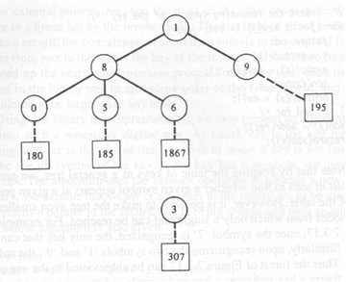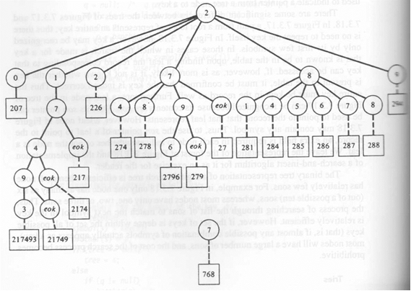
(右邊不清楚部分由上而下分別是 9、294)
Figure 7.3.18 Condensed forest representing a table of keys.

